PCR Application
———
User Guide

Volunteer Crisis Response Team
University of Ottawa

Version 1.0 — August 2026
This guide covers day-to-day use of the PCR application for responders. For account setup, approvals, and system administration, see the separate Administrator Guide.

Contents
1. Introduction
2. Logging In
3. The Dashboard
4. Report Statuses
5. Starting a New PCR
6. Filling Out the Form
Basic Information
Patient Information
Patient Medical History
Treatment Performed
OPQRST Assessment and Injury Location
Vital Signs
Oxygen Protocol
Additional Information
Additional Attachments
Add Signatures
7. Saving a Draft
8. Resuming a Draft
9. Submitting a Report
10. Viewing Your Reports
11. What Happens After You Submit
12. If the Admin Sends a Report Back for Changes
13. Deleting a Draft
14. Logging Out
15. Quick Reference

1. Introduction
The PCR application is where VCRT responders fill out and submit Patient Care Reports (PCRs) after a call. Every report you submit is reviewed by an administrator, who either approves it or sends it back to you with comments if something needs to be fixed.
This guide walks through every screen and every field in the application, in the order you'll actually use them: logging in, filling out a report, saving your work, submitting, and handling a report that gets sent back for changes.
Note Screenshots in this guide were taken from a test copy of the application, so the names, dates, and report numbers you see won't match your real reports. The layout and behaviour are the same.

2. Logging In
Open the PCR application. You'll land on the login screen.
1. Type your username into the Username field.
2. Type your password into the Password field. Click the eye icon inside the field if you want to check what you typed before submitting.
3. Click Sign In.
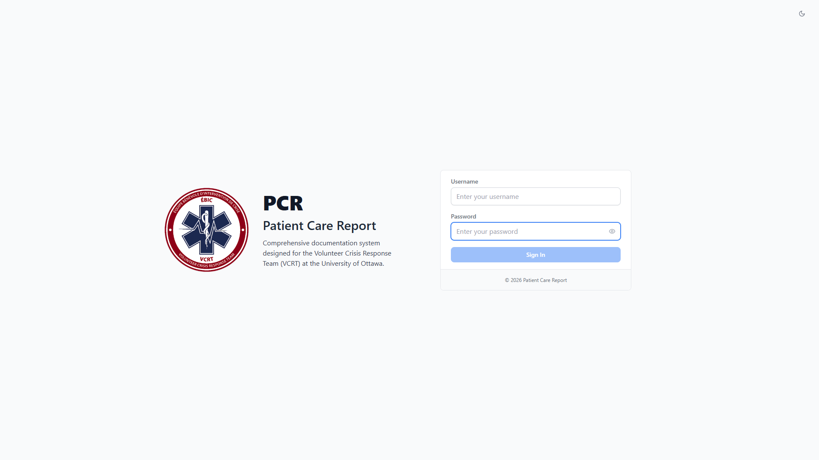
Figure 1. The login screen.
If your username or password is wrong, the form will show an error message and let you try again. If you've forgotten your password, an administrator can reset it for you.
Note After a period of inactivity you'll be signed out automatically and returned to this screen. This is a security measure, not a bug.

3. The Dashboard
Once you're signed in, you land on the Dashboard. This is your home screen and shows a quick summary of your own activity, plus a few reference tools.
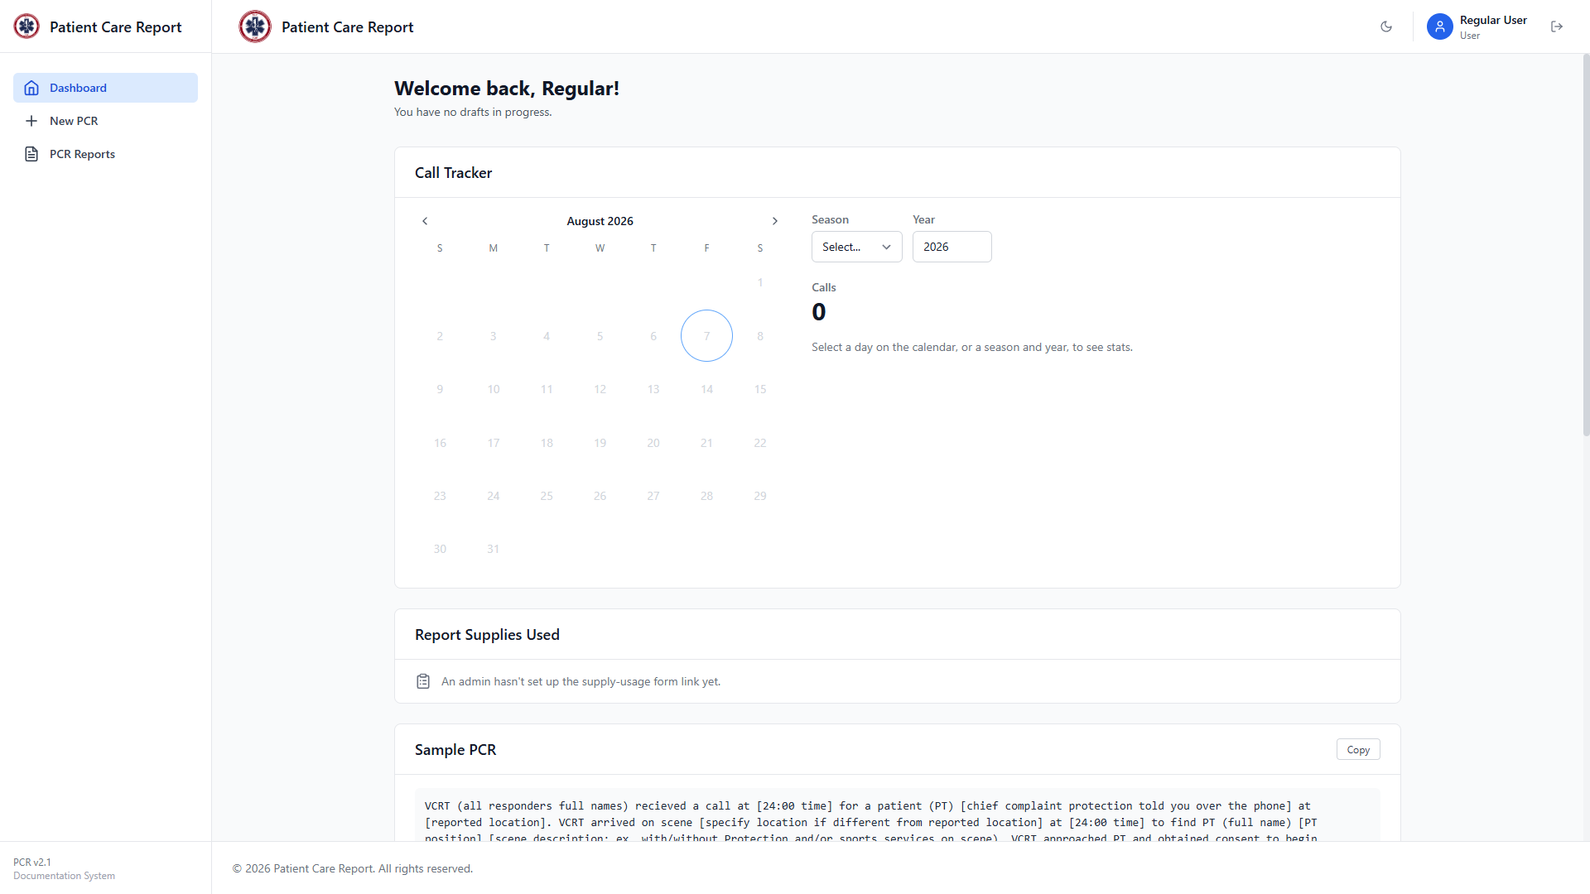
Figure 2. The Dashboard, top of page: welcome message, drafts in progress, and the Call Tracker.
- Drafts in Progress: if you have any saved drafts, they're listed here with a shortcut straight back into the form. This card only appears when you have at least one draft.
- Call Tracker: a calendar showing which days you responded to a call. Select a season and year, or click a specific day, to see your call count.
Scrolling down the Dashboard shows a few more sections:

Figure 3. The Dashboard, further down: supply reporting, sample PCR, and reference material.
- Report Supplies Used: a link (as text or a QR code) to the supply-usage form, if an admin has set one up. If you see "An admin hasn't set up the supply-usage form link yet," nothing is broken — it just hasn't been configured.
- Sample PCR: an example of a well-written call description, for reference when you're writing your own. Click Copy to copy the text.
- Medical Glossary and Debrief Questions: further down the page, these are reference material — common medical abbreviations and a set of standard debrief questions to ask after a call.
The sidebar on the left is how you navigate the rest of the application: Dashboard, New PCR, and PCR Reports.

4. Report Statuses
Every PCR you create is always in one of four states. Understanding these up front makes the rest of the application much easier to follow.
Status | What it means for you
Draft | Saved but not submitted. Only you can see it, and you can edit or delete it freely.
Submitted | Sent to the admin for review. You can no longer edit or delete it, but you can still view the PDF.
Changes Requested | The admin reviewed it and asked you to fix something. You can edit it again and resubmit it, but you can't delete it yourself.
Approved | The admin signed off on it. The report is now final — see the note below.

Note Once a report is Approved, it no longer appears anywhere in your PCR Reports list. This is intentional: approved reports are finalized records, and editing or viewing access moves to the administrators who maintain them. If you need a copy of an approved report, contact an admin.

5. Starting a New PCR
1. Click New PCR in the left sidebar.
You'll get a blank form. It's long, so the rest of this guide walks through it one section at a time, in the order they appear on the page.
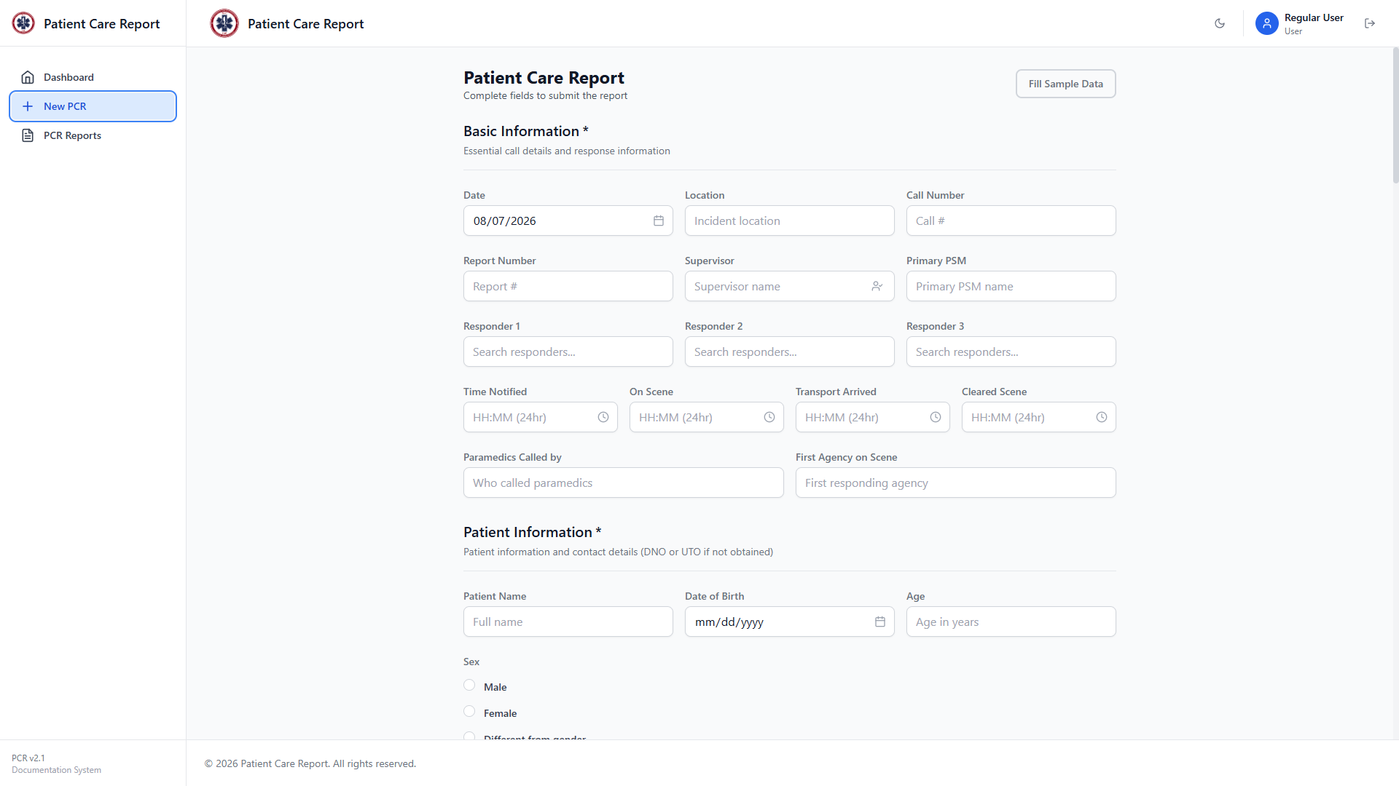
Figure 4. The top of a blank PCR form: Basic Information.
Note The Fill Sample Data button in the top-right corner fills the entire form with placeholder text. It exists for testing and demonstrations — don't use it on a real report.

6. Filling Out the Form
Fields marked with a red asterisk (*) next to the section title, or shown with "DNO or UTO if not obtained" in the subtitle, are required before you can submit. "DNO" means Did Not Obtain and "UTO" means Unable To Obtain — use one of these instead of leaving a required field blank if you genuinely couldn't get that information on scene.

Basic Information
Required. Essential details about the call itself.
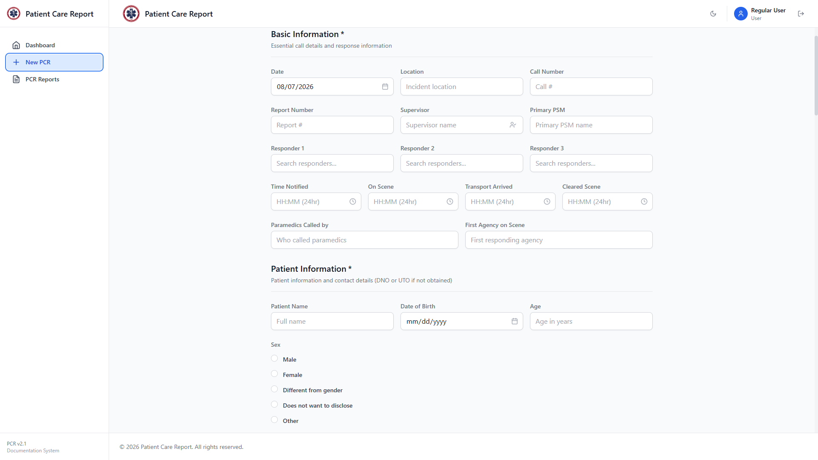
Figure 5. The Basic Information section.
- Date: defaults to today. Change it if you're filing the report after the fact.
- Location: where the call took place.
- Call Number: the internal call number for this response.
- Report Number: this report's unique reference number.
- Supervisor: the supervisor on duty for this call.
- Primary PSM: the primary PSM's name for this call.
- Responder 1, 2, 3: search and select the responders present. This searches the admin-managed responder list, but you can also type a name that isn't on the list.
- Time Notified, On Scene, Transport Arrived, Cleared Scene: enter times in 24-hour HH:MM format (for example, 19:42).
- Paramedics Called By: who called paramedics, if applicable.
- First Agency on Scene: required. Which agency arrived first.

Patient Information
Required. Use DNO or UTO for anything you genuinely couldn't obtain.
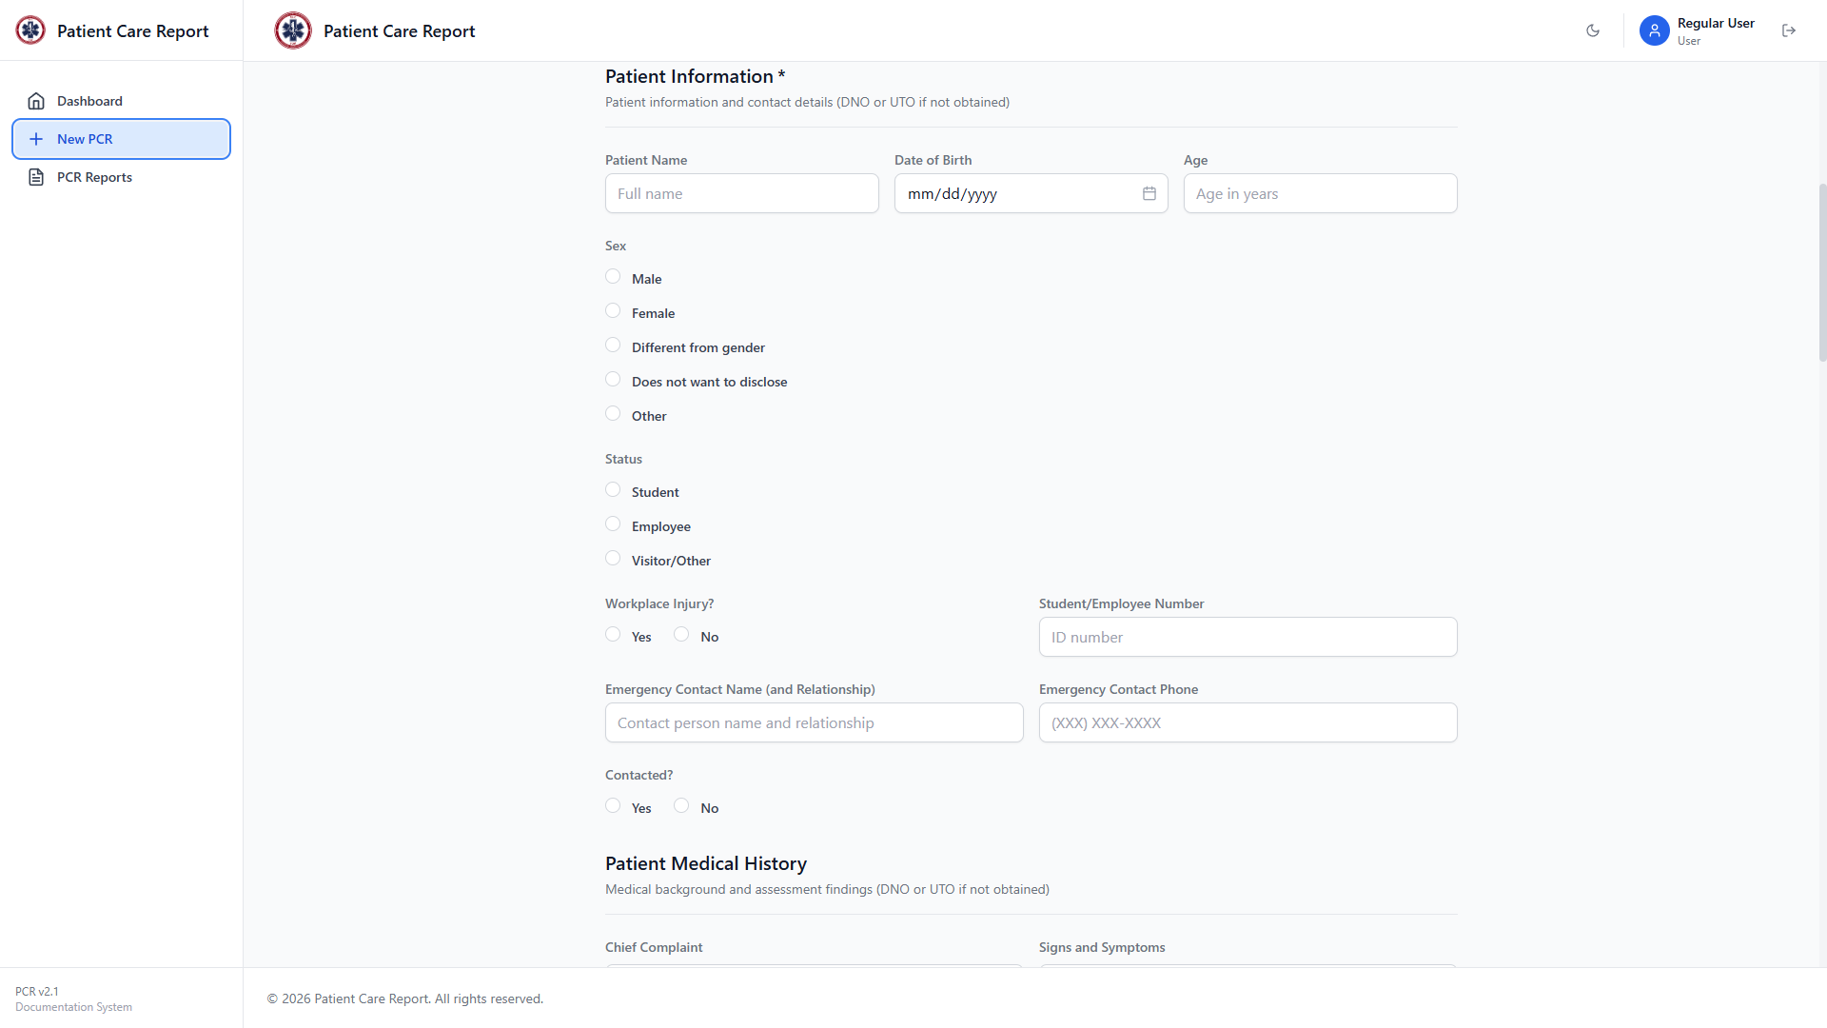
Figure 6. The Patient Information section.
- Patient Name
- Date of Birth or Age: at least one of the two is required.
- Sex: Male, Female, Different from gender, Does not want to disclose, or Other.
- Status: Student, Employee, or Visitor/Other. If you pick Visitor/Other, a field appears to specify further.
- Workplace Injury?: Yes or No.
- Student/Employee Number
- Emergency Contact Name (and Relationship), Emergency Contact Phone
- Contacted?: Yes or No. If Yes, a Contacted by field appears for who made the call.

Patient Medical History
Not marked required by the form itself, but treat every field here as DNO/UTO if you didn't obtain it — an admin reviewing the report will expect an answer either way.
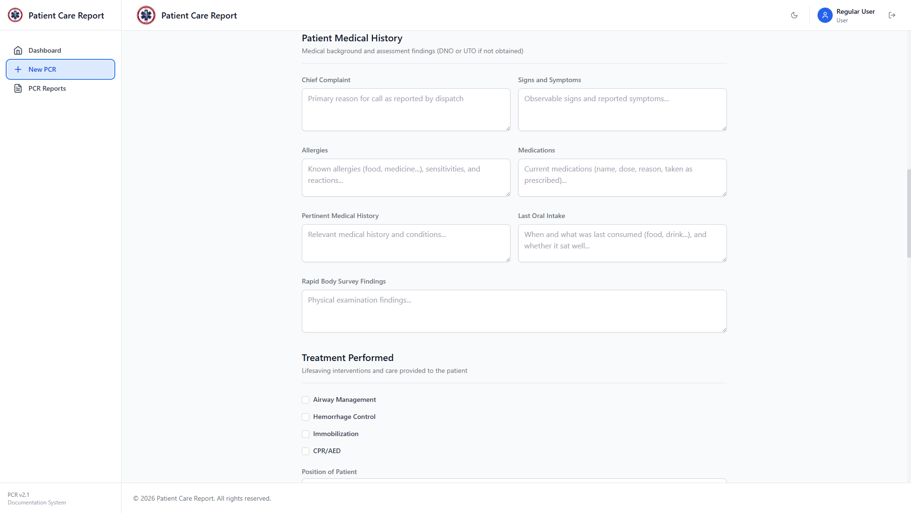
Figure 7. The Patient Medical History section.
- Chief Complaint: the primary reason for the call, as reported.
- Signs and Symptoms: what you observed and what the patient reported.
- Allergies: known allergies, sensitivities, and reactions.
- Medications: current medications: name, dose, reason, and whether taken as prescribed.
- Pertinent Medical History: relevant conditions and history.
- Last Oral Intake: when and what was last consumed, and whether it sat well.
- Rapid Body Survey Findings: what you found on physical examination.

Treatment Performed
Check every box that applies. Some selections reveal extra fields.
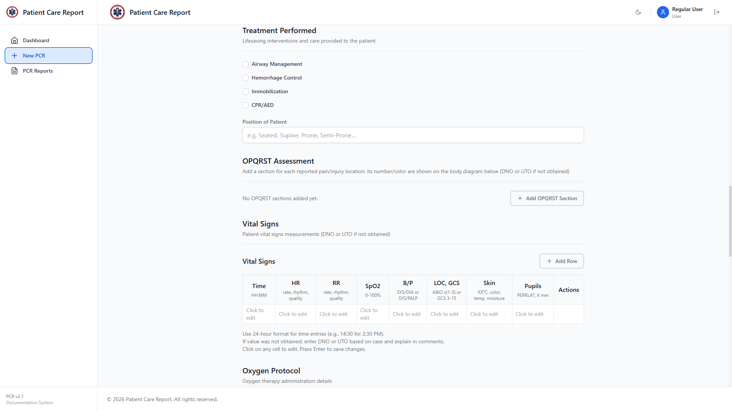
Figure 8. The Treatment Performed section.
- Airway Management: Suctioning, Positioning, OPA, BVM, Pocket Mask.
- Hemorrhage Control: Direct Pressure, Dressing, Tourniquet. Checking Tourniquet reveals Time Applied and Number of Turns fields.
- Immobilization: C-Collar, Splints, C-spine Manually Held.
- CPR/AED: check this box first if CPR or AED was used. Two sub-checkboxes appear — CPR and AED — each of which reveals its own timing fields (Time Started and Number of Cycles for CPR; Shocks and Shock Not Advised counts for AED).
- Position of Patient: required. For example: Seated, Supine, Prone, Semi-Prone.

OPQRST Assessment and Injury Location
OPQRST documents pain or injury in detail. You can add up to four OPQRST sections, one per injury or complaint. Click Add OPQRST Section to add one.
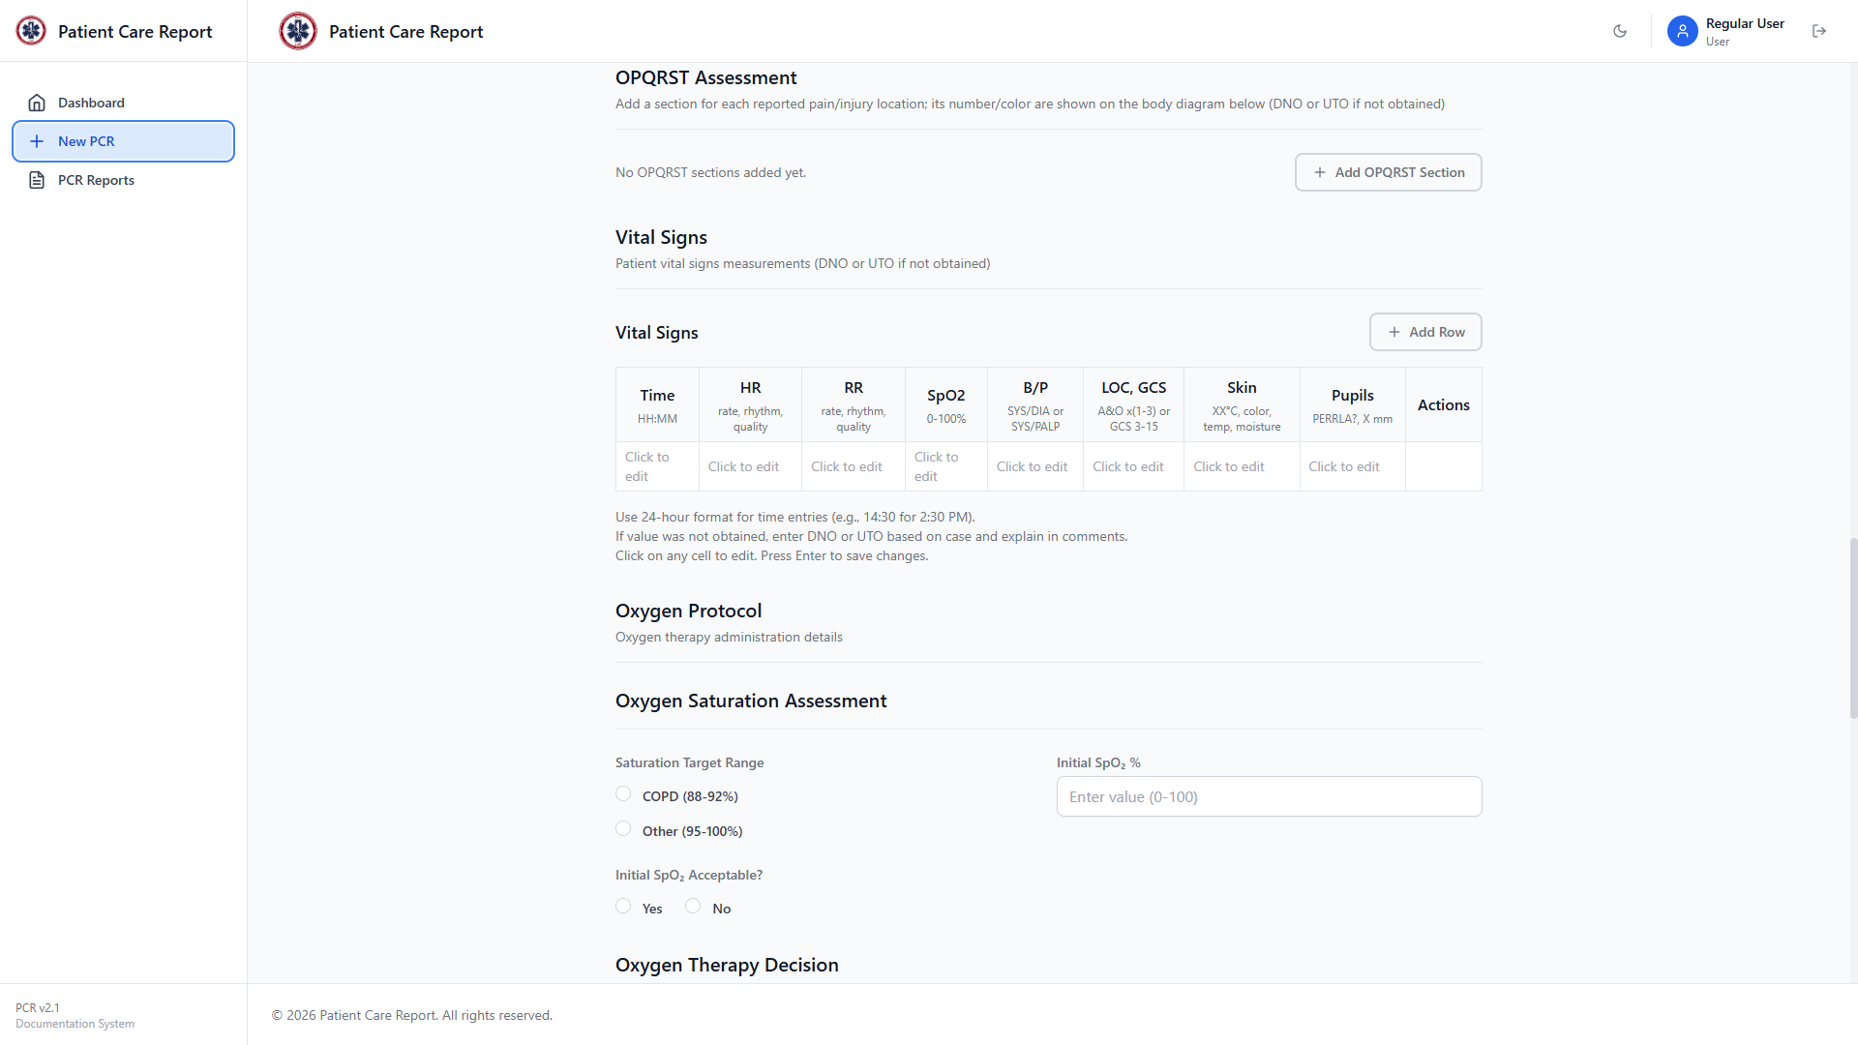
Figure 9. The OPQRST Assessment section, before any entries are added.
- Area / Location: where on the body, e.g. Left knee, Chest, Lower back.
- Onset: acute or chronic, and how it started.
- Provocation: what makes it better or worse.
- Quality: how it feels — sharp, dull, throbbing, and so on.
- Radiation: where the pain spreads to, if anywhere.
- Scale: pain rating from 1 to 10.
- Time: when it occurred.
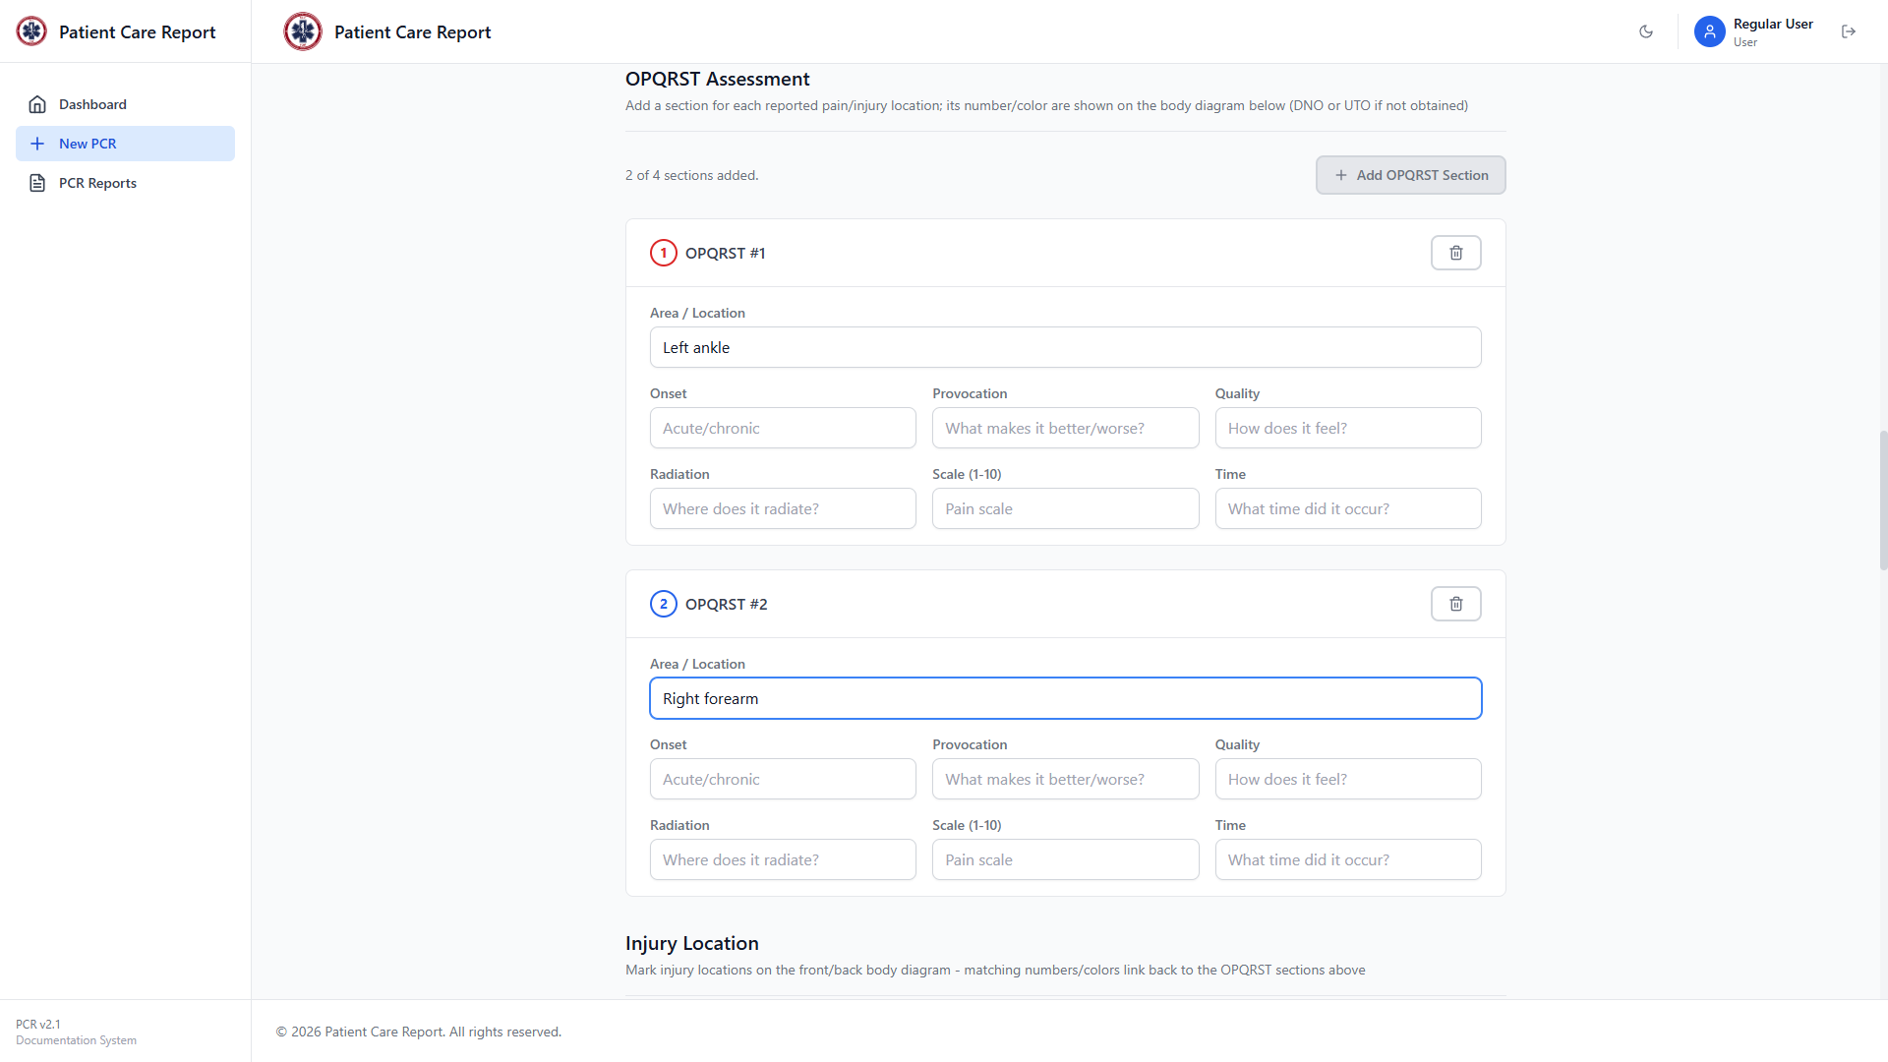
Figure 10. Two OPQRST entries added — each gets its own number and colour, shown on the left of its card.
Each OPQRST entry is numbered and colour-coded. Once you've added at least one, an Injury Location section appears below it with front and back body diagrams, for marking exactly where each numbered injury is.
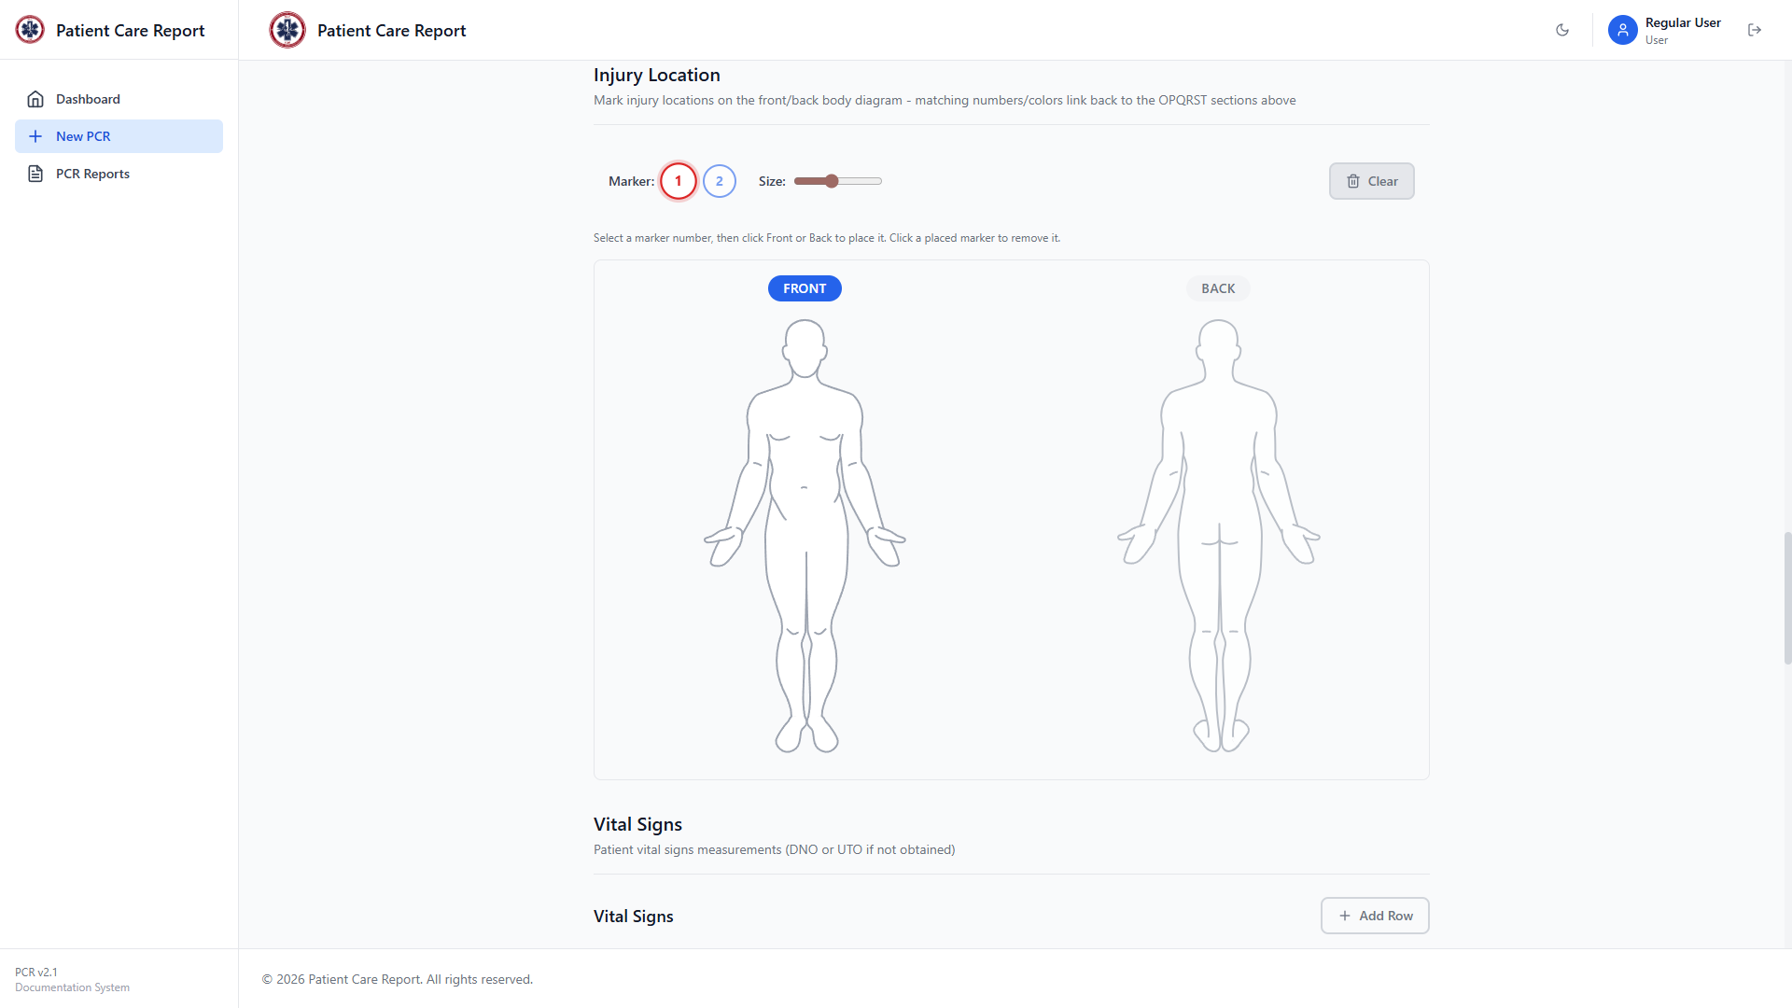
Figure 11. The Injury Location section: pick a marker number and size, then click the body diagram to place it.
1. Pick the marker number that matches the OPQRST entry you're marking — the colours match the numbers on the OPQRST cards above.
2. Drag the Size slider if you want this marker larger or smaller than the default. This only sets the size of the next marker you place — it doesn't resize markers already on the diagram.
3. Click Front or Back to switch views, then click on the body diagram at the injury location.
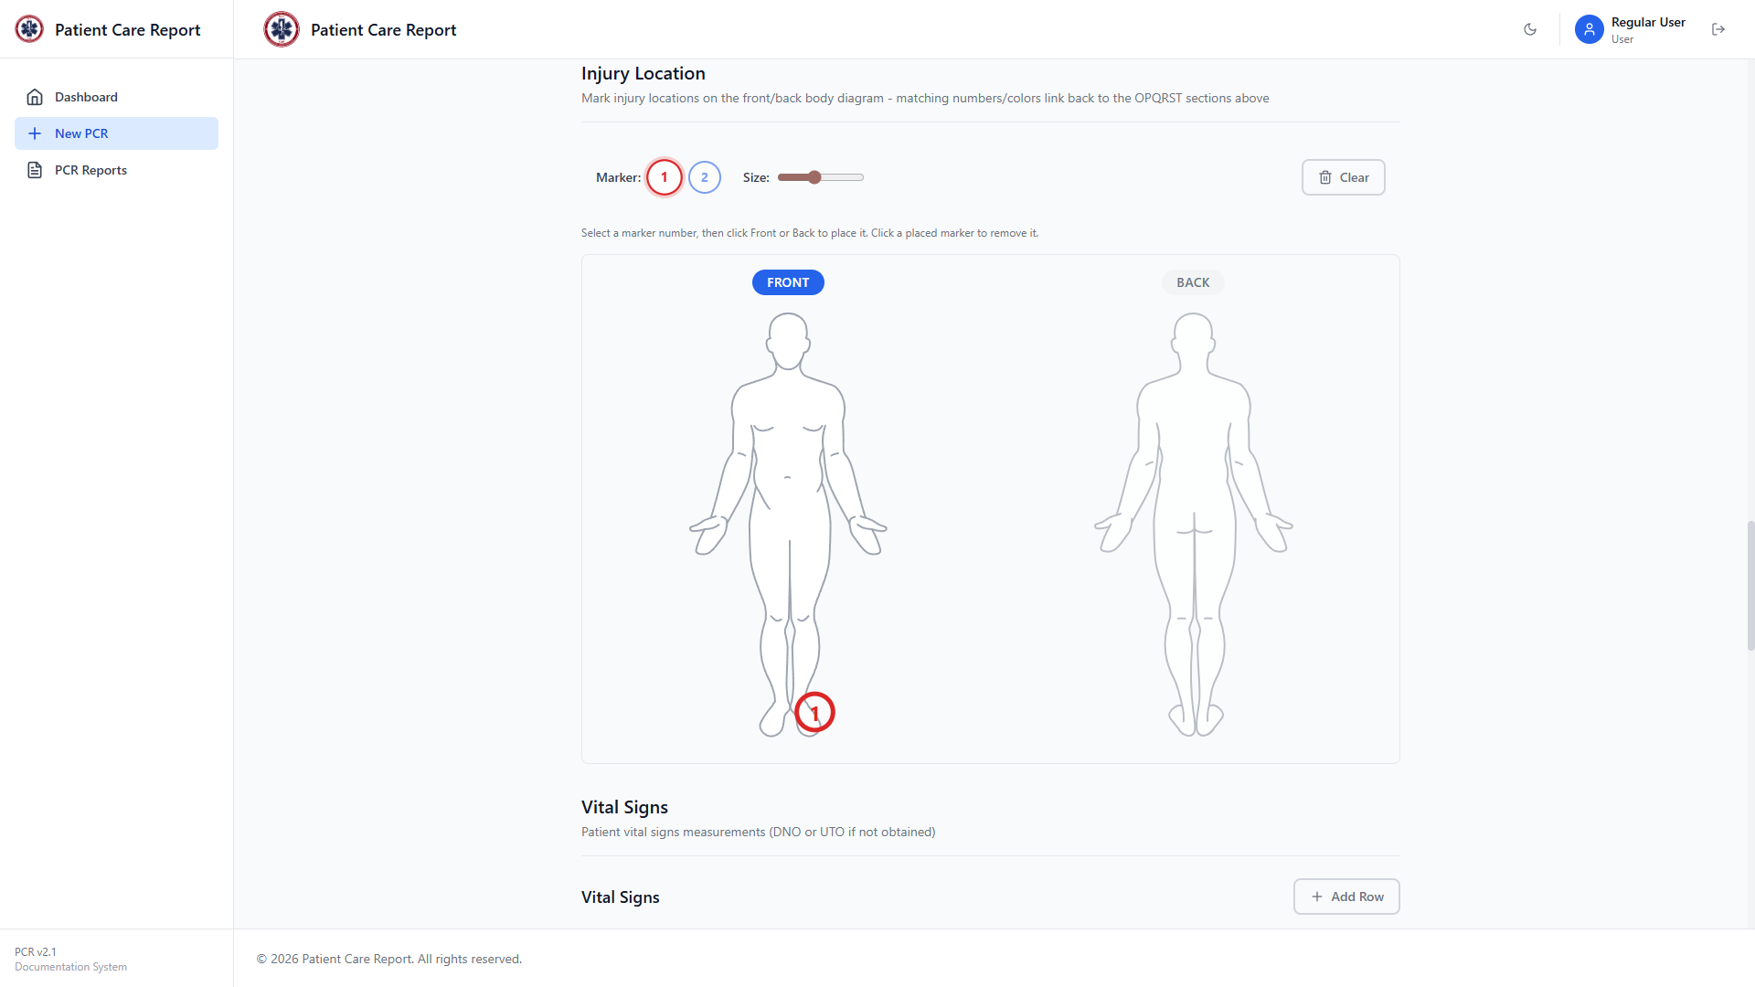
Figure 12. Marker 1 placed on the front diagram at the default size.
4. To compare sizes, select a different marker number, move the Size slider, and place it elsewhere. Here, marker 2 was placed at the largest available size.
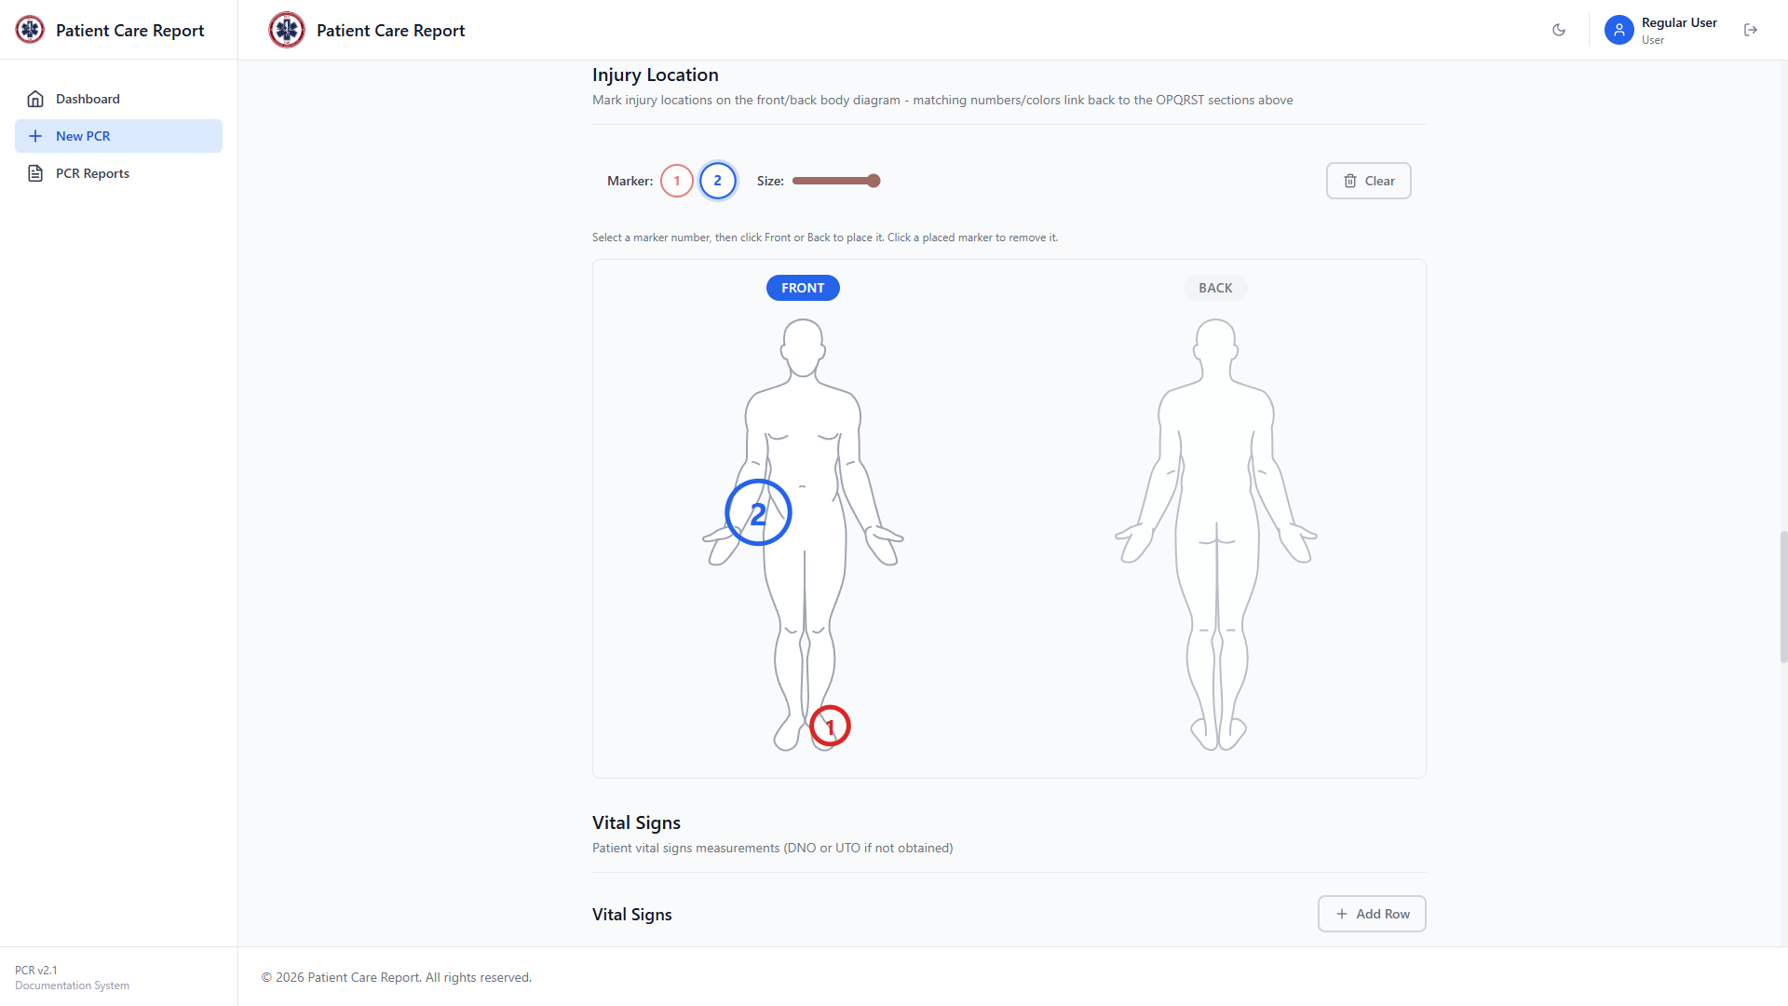
Figure 13. Two markers on the same diagram: marker 1 at the default size, marker 2 at the largest size.
Note Click a marker that's already been placed to remove it. There's no drag-to-resize — decide the size on the slider before you click to place it.

Vital Signs
A table for recording one or more sets of vitals over time. Add a row for each set you take during the call (up to 8 rows). Click a cell to edit it.
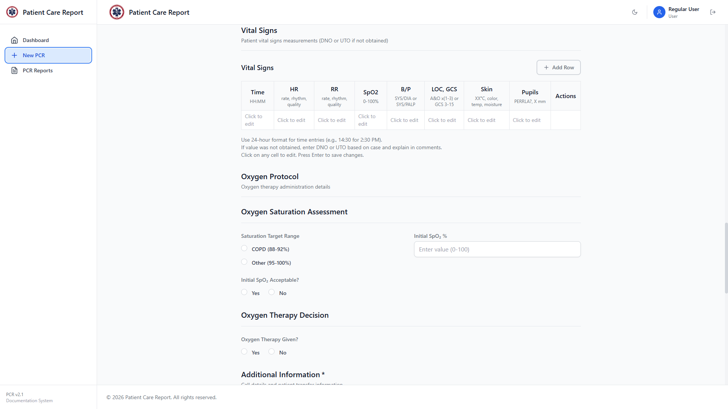
Figure 14. The Vital Signs table.
- Time: HH:MM.
- HR: heart rate: rate, rhythm, and quality.
- RR: respiratory rate: rate, rhythm, and quality.
- SpO2: oxygen saturation, 0–100%.
- B/P: blood pressure, as SYS/DIA or SYS/PALP.
- LOC, GCS: level of consciousness — A&O x1 through x3, or a Glasgow Coma Scale score from 3 to 15.
- Skin: temperature, colour, and moisture.
- Pupils: PERRLA (Pupils Equal, Round, Reactive to Light and Accommodation) or a size in mm.
Note Use 24-hour time. If a value wasn't obtained, enter DNO or UTO and explain in the Call Description. Click any cell to edit it, and press Enter to save.

Oxygen Protocol
Fill this in if oxygen therapy was given or considered. It has two parts: Oxygen Saturation Assessment and Oxygen Therapy Decision.
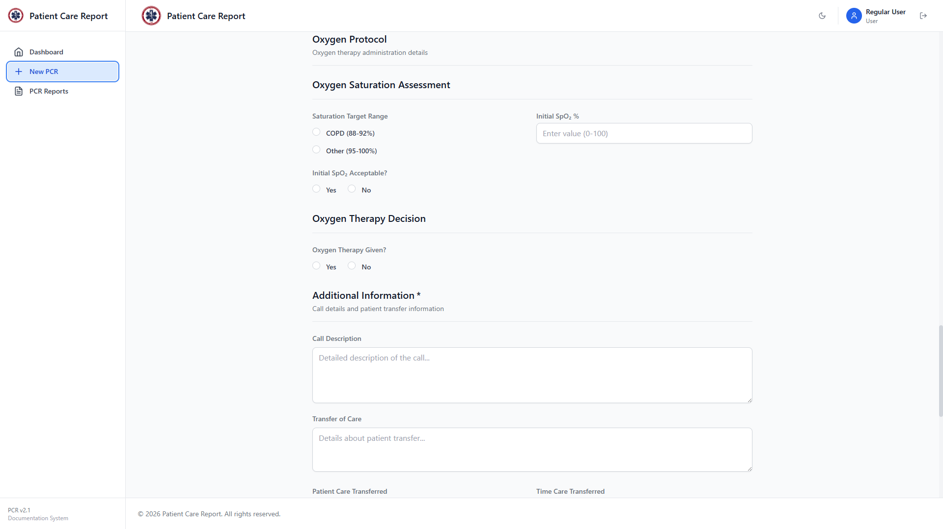
Figure 15. The Oxygen Protocol section.
- Saturation Target Range: COPD (88–92%) or Other (95–100%).
- Initial SpO₂ %: the reading before any intervention.
- Initial SpO₂ Acceptable?: Yes or No, given the target range you selected.
- Oxygen Therapy Given?: Yes or No. Selecting Yes reveals further fields for the delivery device (Nasal Cannula, Non-Rebreather Mask, or Bag Valve Mask) and who started it.
- Flow rate alterations: if the flow rate was changed during the call, add a row for each change with the time and new rate.

Additional Information
Required. This is the narrative section of the report — how the call unfolded and how it ended.
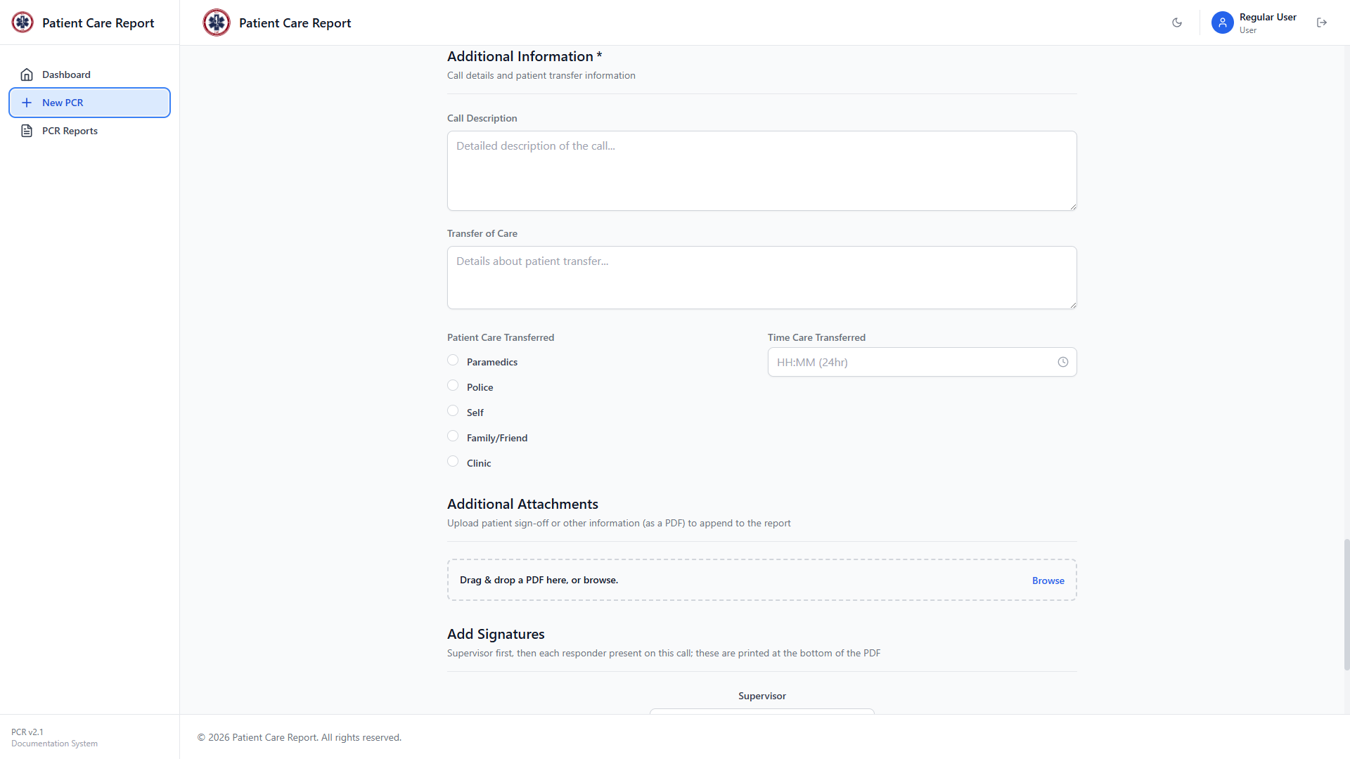
Figure 16. The Additional Information section.
- Call Description: required. A detailed, chronological account of the call: who responded, what was found, what was done, and by whom. The Sample PCR card on the Dashboard is a good model for the level of detail expected here.
- Transfer of Care: required. What was handed off, to whom, and the patient's condition at handoff.
- Patient Care Transferred: required. Paramedics, Police, Self, Family/Friend, or Clinic. Depending on your choice, an extra field appears: Unit Number and Hospital Destination for Paramedics, Badge Number for Police, or Clinic Name for Clinic.
- Time Care Transferred: required. 24-hour HH:MM format.

Additional Attachments
Optional. If you have a signed patient sign-off sheet or other document as a PDF, attach it here — it will be appended to the end of the generated PDF report.
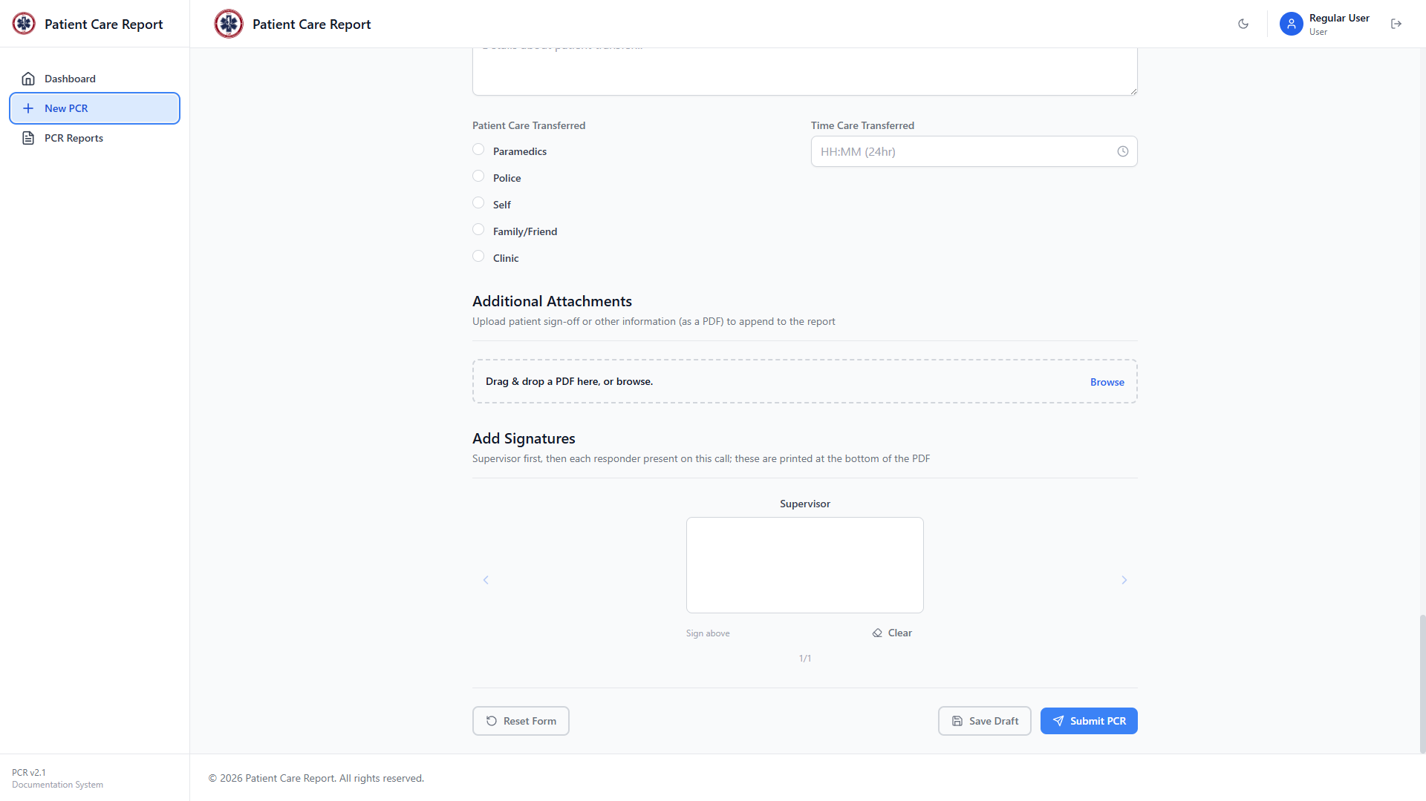
Figure 17. The Additional Attachments upload area.
1. Drag and drop a PDF onto the box, or click Browse to pick a file.
2. The file name appears once it's attached. Click Remove to take it off again.
Note Only PDF files are accepted, up to 15 MB.

Add Signatures
Sign-off from everyone who responded to the call: the supervisor first, then each responder you added in Basic Information. Use the arrows on either side to move between signers.

Figure 18. The Add Signatures section, showing whose turn it is to sign and how many signers remain.
1. Sign in the box using a mouse, stylus, or touchscreen.
2. Click Clear if you need to redo a signature.
3. Use the right arrow to move to the next signer once you're done.

7. Saving a Draft
You don't have to finish the form in one sitting. Click Save Draft at the bottom of the page at any point to save your progress without submitting.
As an example, here's the form after clicking Fill Sample Data to populate every field at once — this is only ever done for demonstrations, but it shows what a filled-in form looks like:
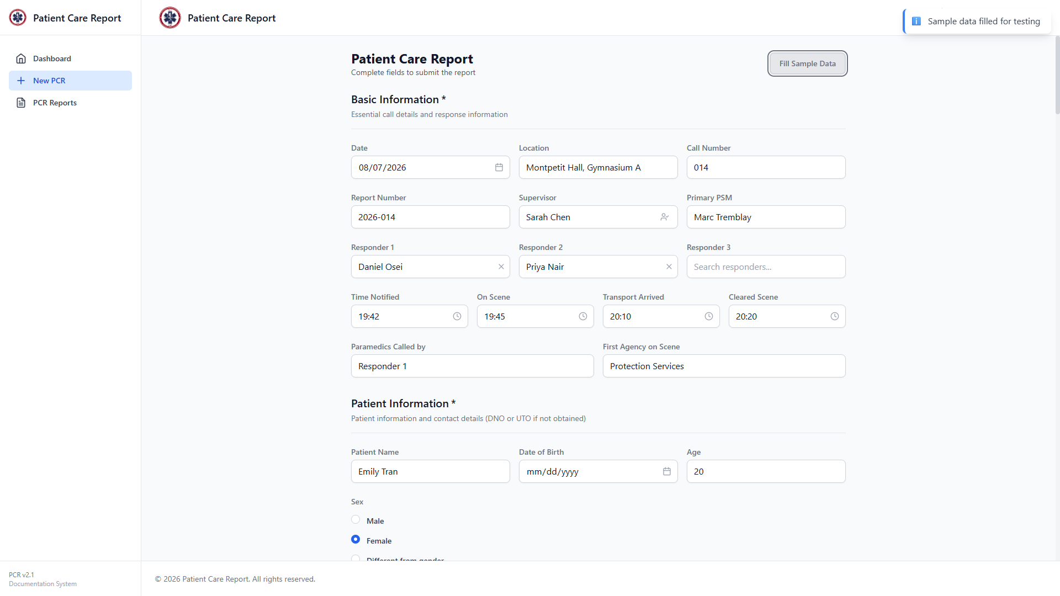
Figure 19. Basic Information and Patient Information after filling in sample data.
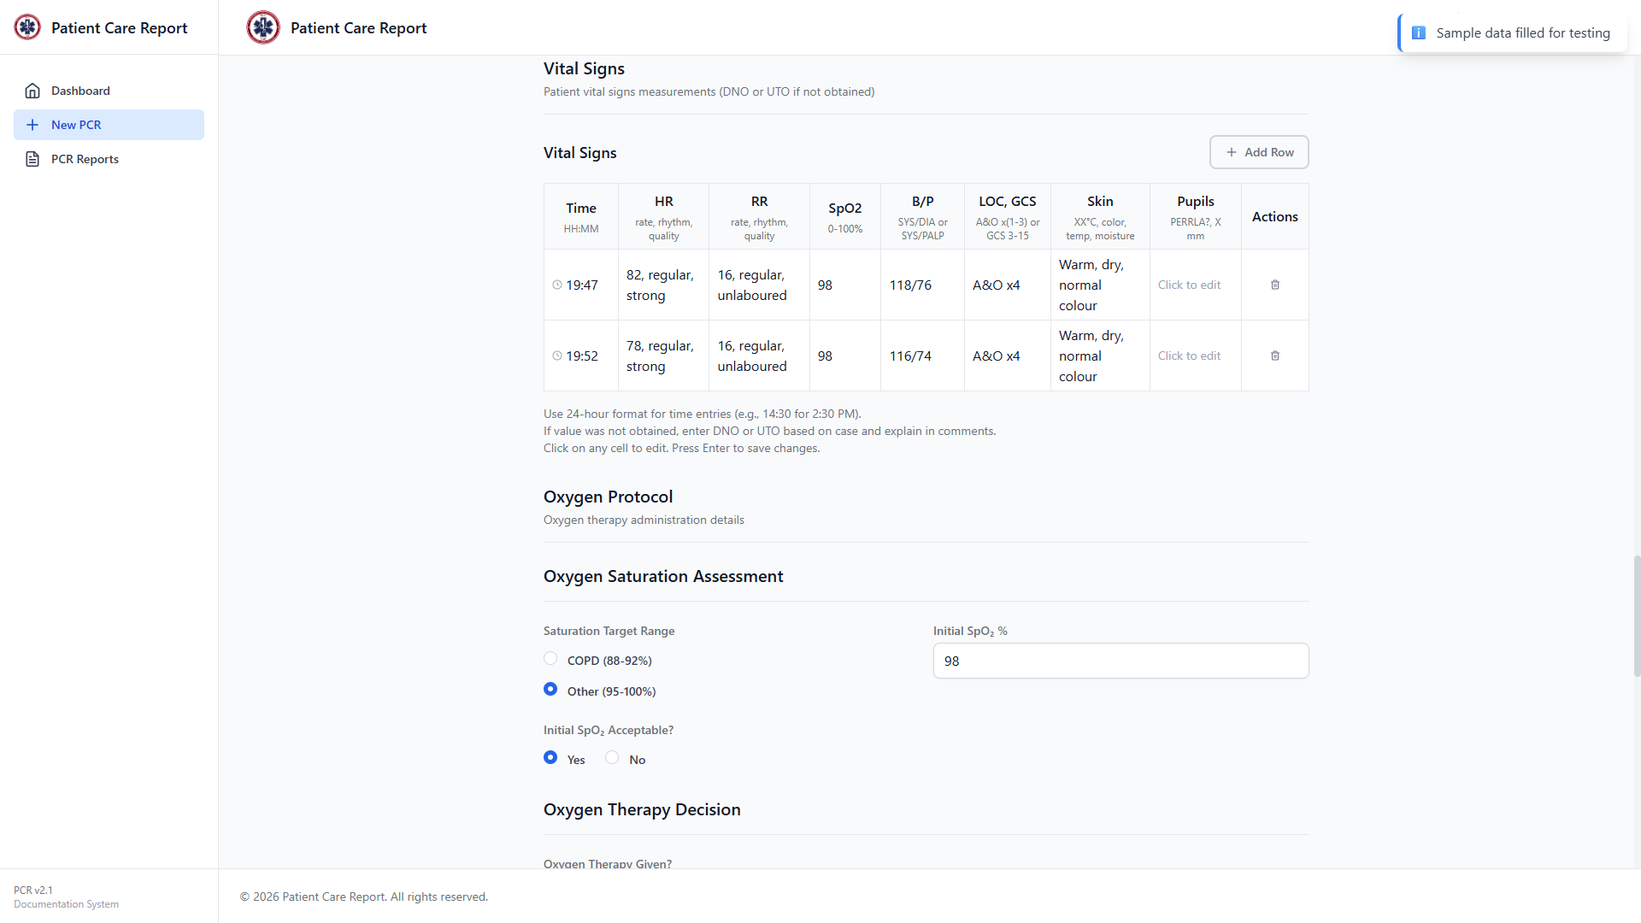
Figure 20. The Vital Signs table with two sets of vitals recorded.
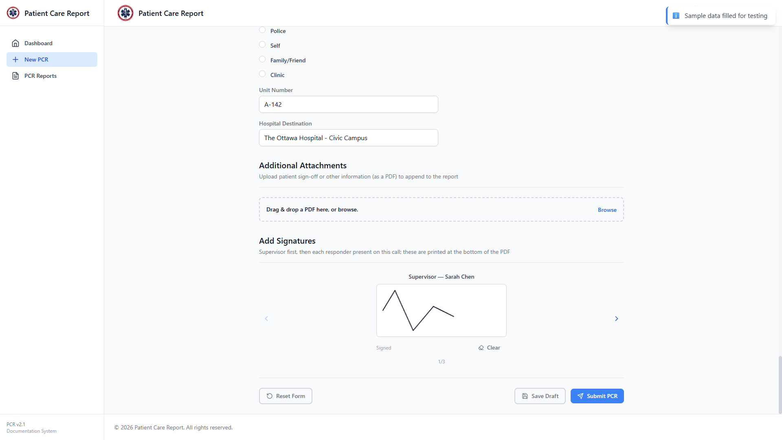
Figure 21. A signature drawn in the signature pad.
Clicking Save Draft stores exactly what you've entered so far, including any signatures and attachments, and shows a confirmation message.
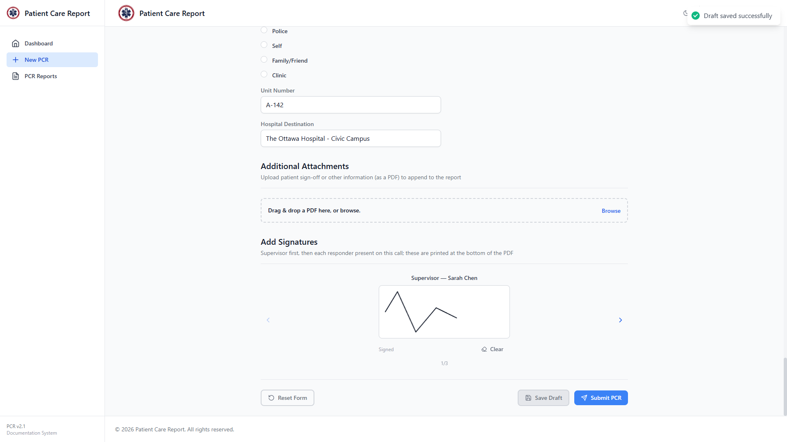
Figure 22. Confirmation after saving a draft.
Note Save Draft never validates required fields. You can save a mostly-empty form as a draft and come back to it later. Validation only happens when you submit.

8. Resuming a Draft
There are two ways back into a saved draft:
- From the Dashboard, under Drafts in Progress, click the draft you want.
- From PCR Reports in the sidebar, find the draft in the list and click Edit.
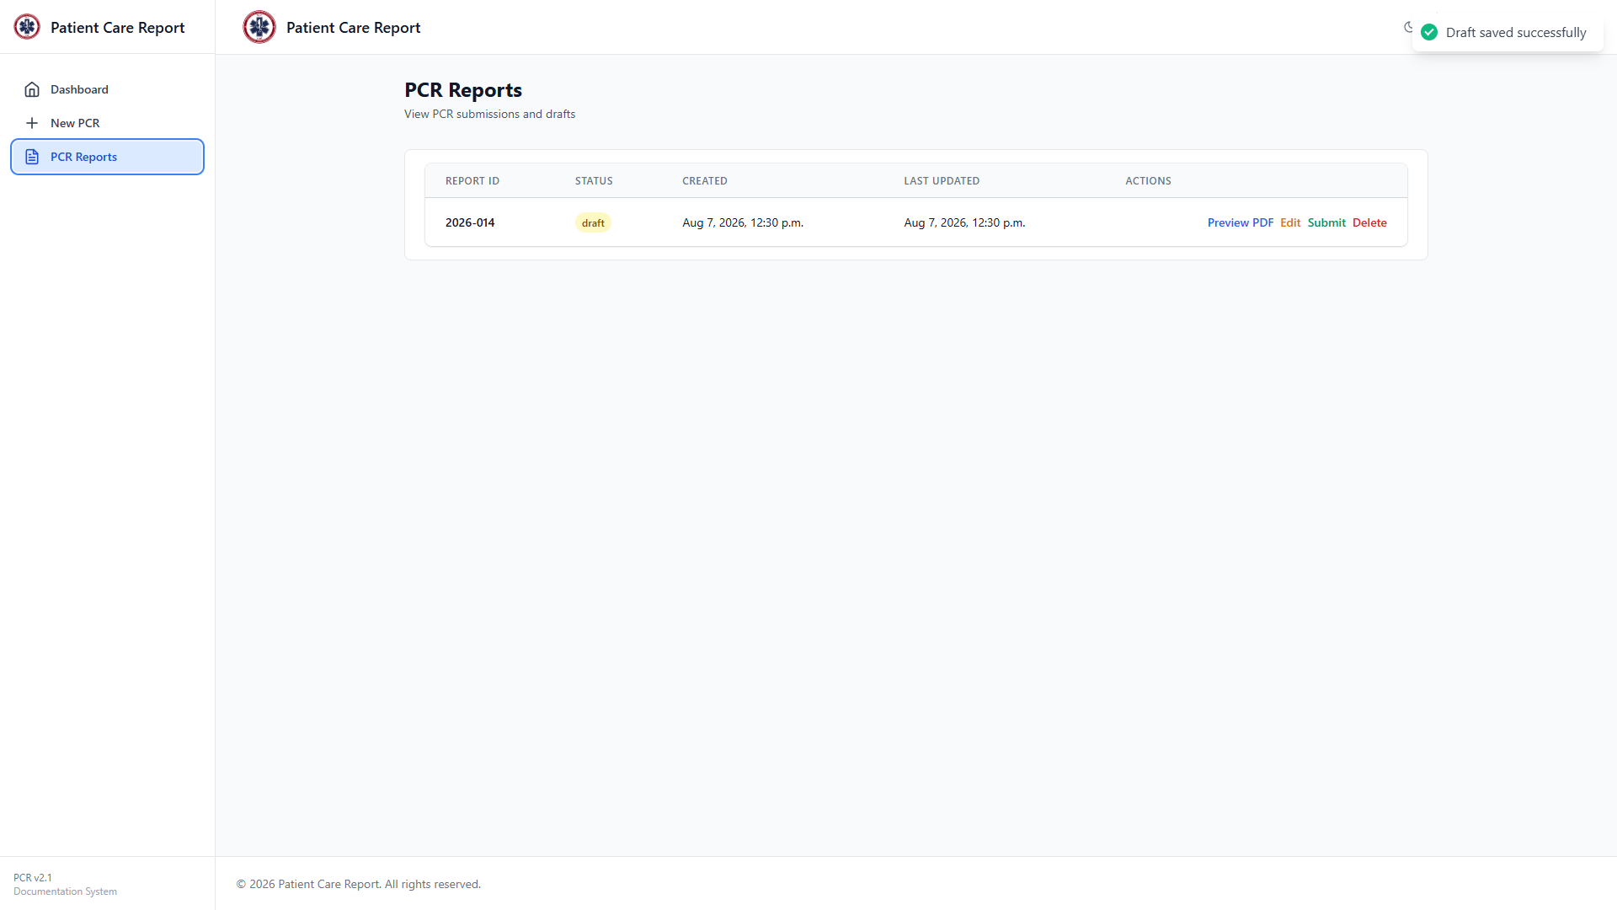
Figure 23. The PCR Reports list, showing one draft with its Preview PDF, Edit, and Submit actions.
Either way, the form reopens with everything you'd already entered, ready to continue.
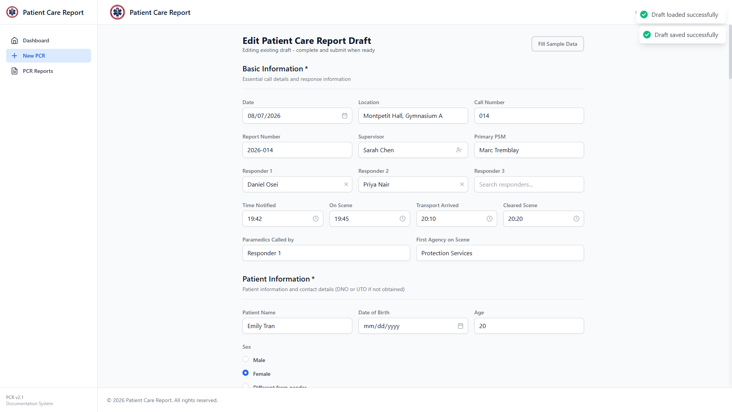
Figure 24. A draft reopened for editing.
Note On the PCR Reports list, a draft row has three actions: Preview PDF (see what it would look like without submitting), Edit, and Submit. Edit and Submit both take you into the form — Submit is just a shortcut for people who are ready to finish and send it right away.

9. Submitting a Report
When the form is complete, click Submit PCR at the bottom of the page.
1. If any required field is missing or invalid, the application tells you which ones and jumps you to the first problem. Fix it and click Submit PCR again.
2. Once validation passes, a PDF of the report is generated and a confirmation window opens.
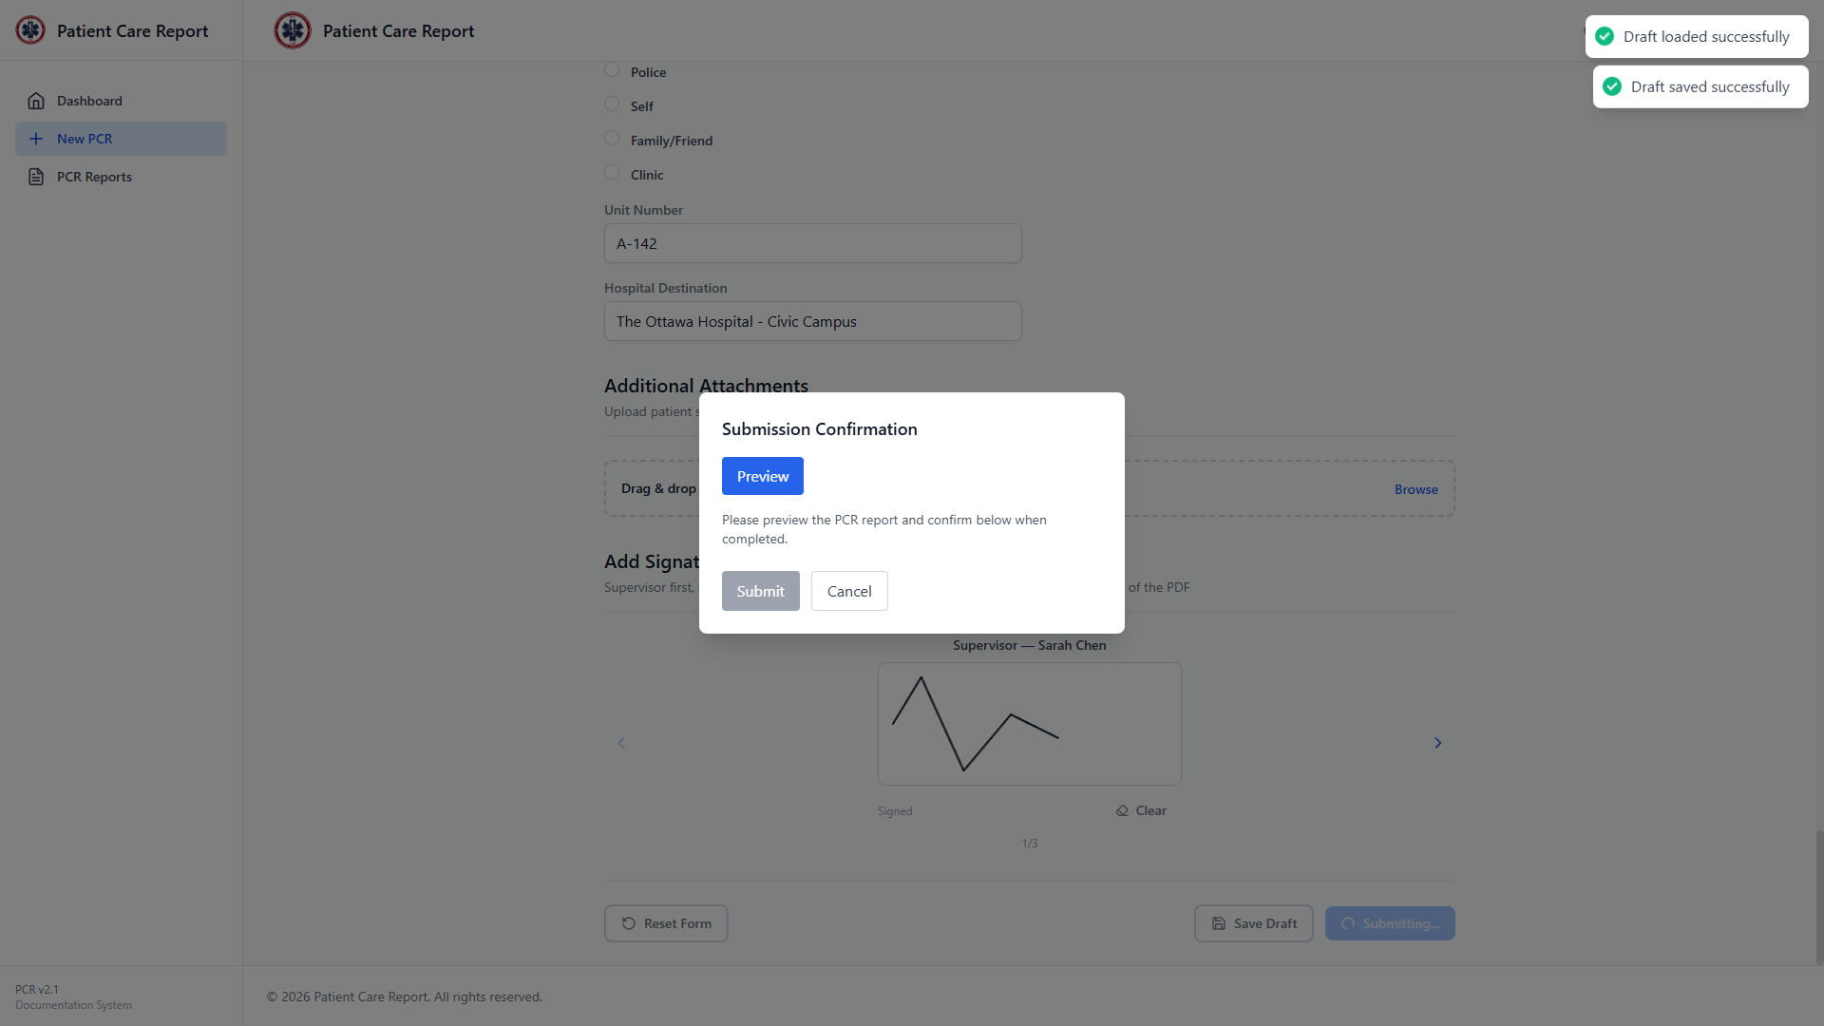
Figure 25. The submission confirmation window.
3. Click Preview to open the generated PDF and check it over.
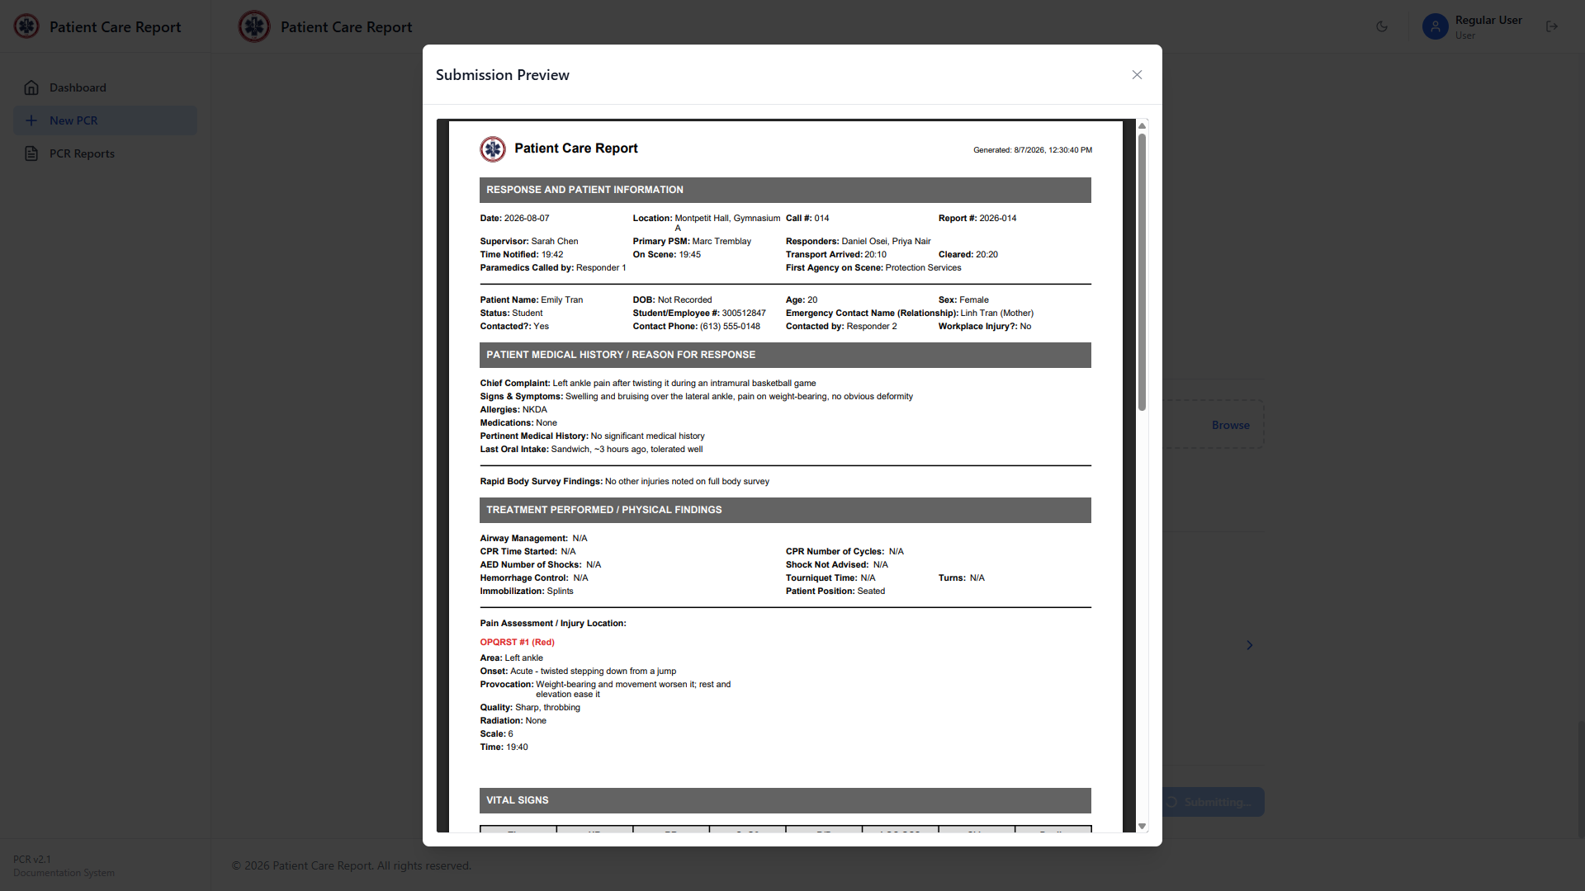
Figure 26. The generated PDF, shown in the preview window.
4. Close the preview. The Submit button in the confirmation window is now enabled.
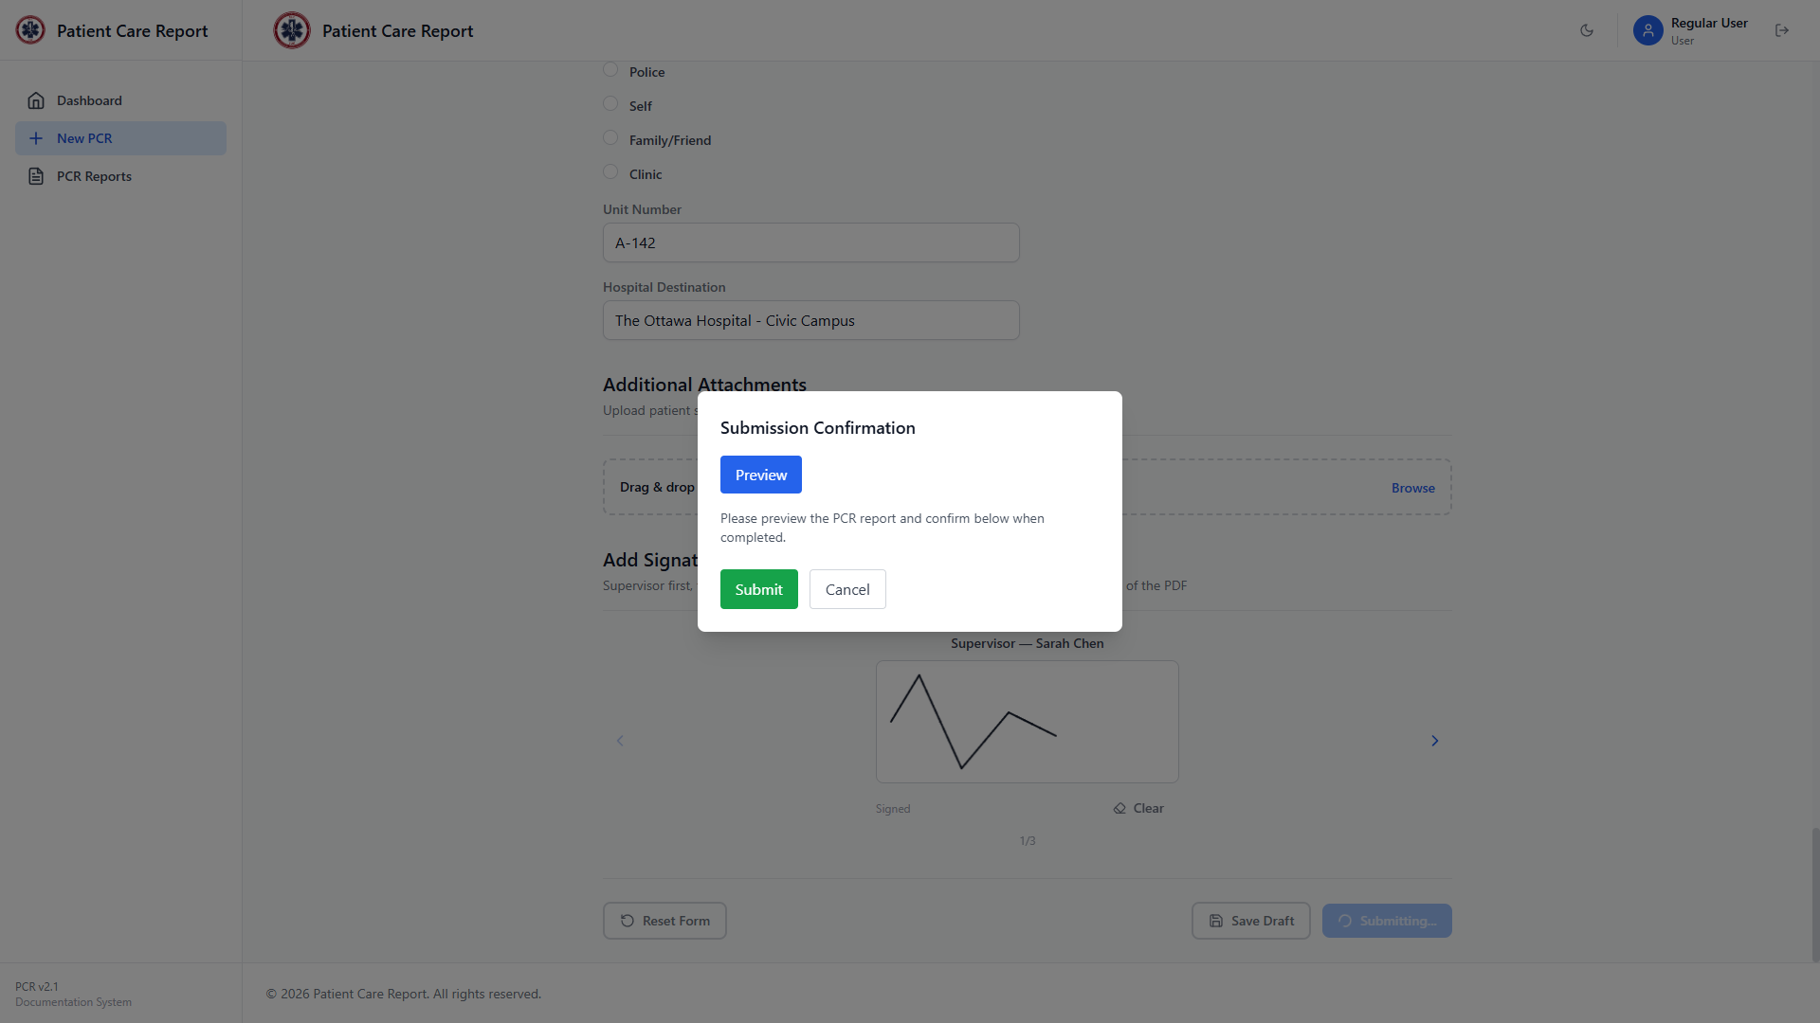
Figure 27. The confirmation window after previewing — Submit is now enabled.
5. Click Submit to send the report to the admin for review, or Cancel to back out without submitting.
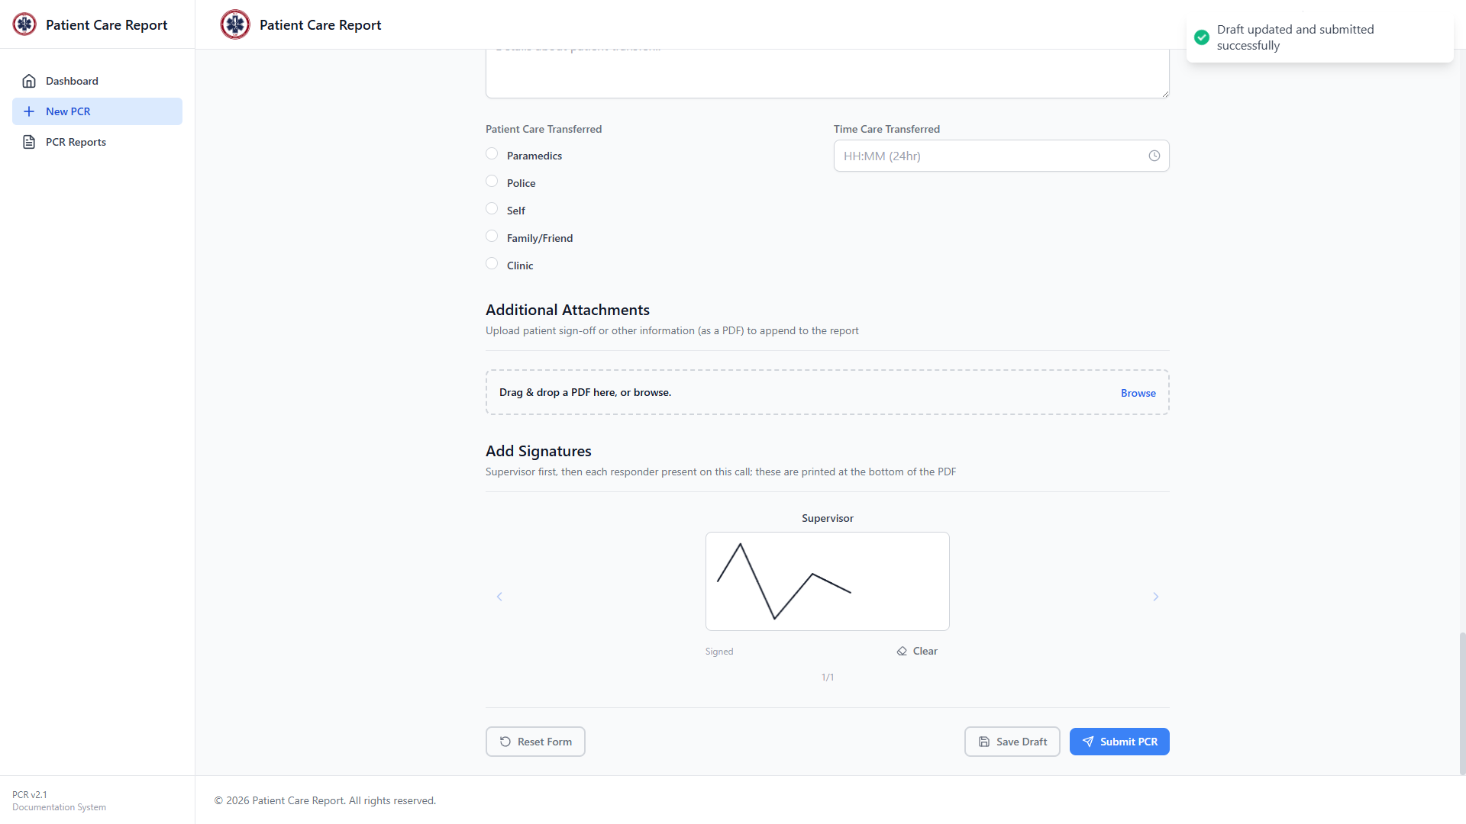
Figure 28. Confirmation after a successful submission.
Note You must open the preview before you can submit. This is a deliberate check so you actually look over the report before it goes to review.

10. Viewing Your Reports
Click PCR Reports in the sidebar to see everything you've created: drafts, submitted reports, and anything sent back to you for changes.
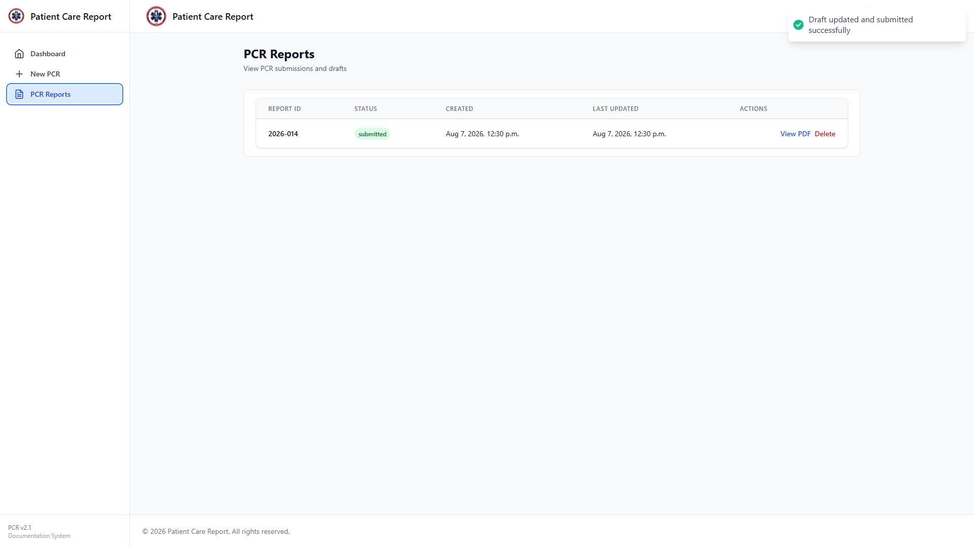
Figure 29. The PCR Reports list with one submitted report.
You can submit as many reports as you need to — the list simply grows as you add more.
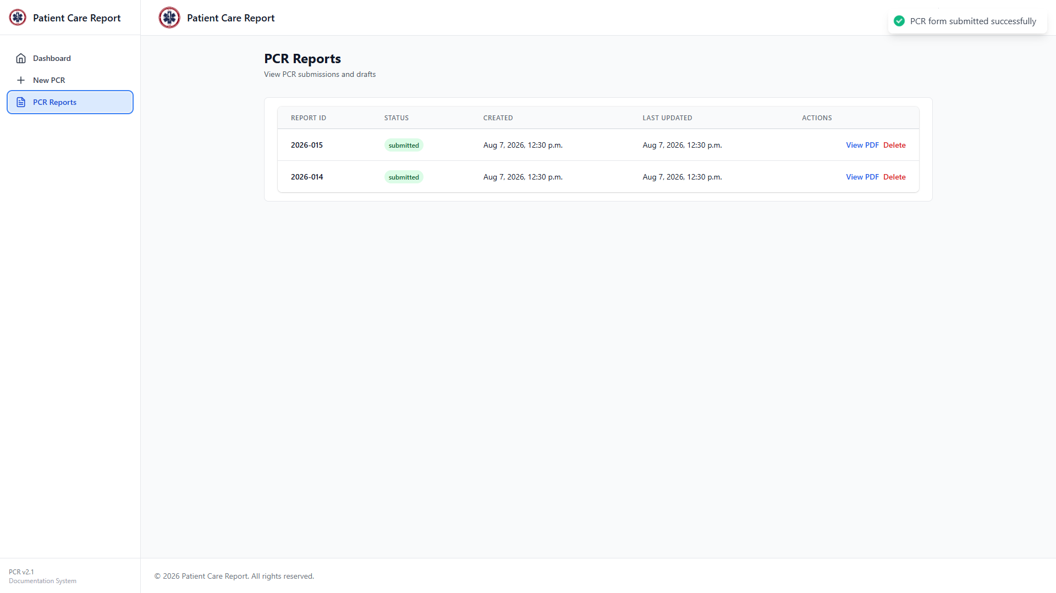
Figure 30. Two submitted reports in the list.
Click View PDF on any row (or click the row itself) to open the generated PDF for that report. As a regular user, you can view and print from this preview, but downloading a copy to your device is restricted to administrators.

11. What Happens After You Submit
A submitted report is reviewed by an administrator, who does one of two things:
- Approves it. The report is now final, and it drops off your PCR Reports list — see Section 4 for why.
- Sends it back with comments, asking you to fix something. Its status changes to Changes Requested and it stays in your list until you resubmit it.
There's no notification inside the application when this happens — check your PCR Reports list periodically, especially after submitting a report, to see whether it's still pending, has been approved, or needs changes.

12. If the Admin Sends a Report Back for Changes
If a report needs correction, its status changes to Changes Requested and you get an Edit & Resubmit action, along with a link to the admin's comments.
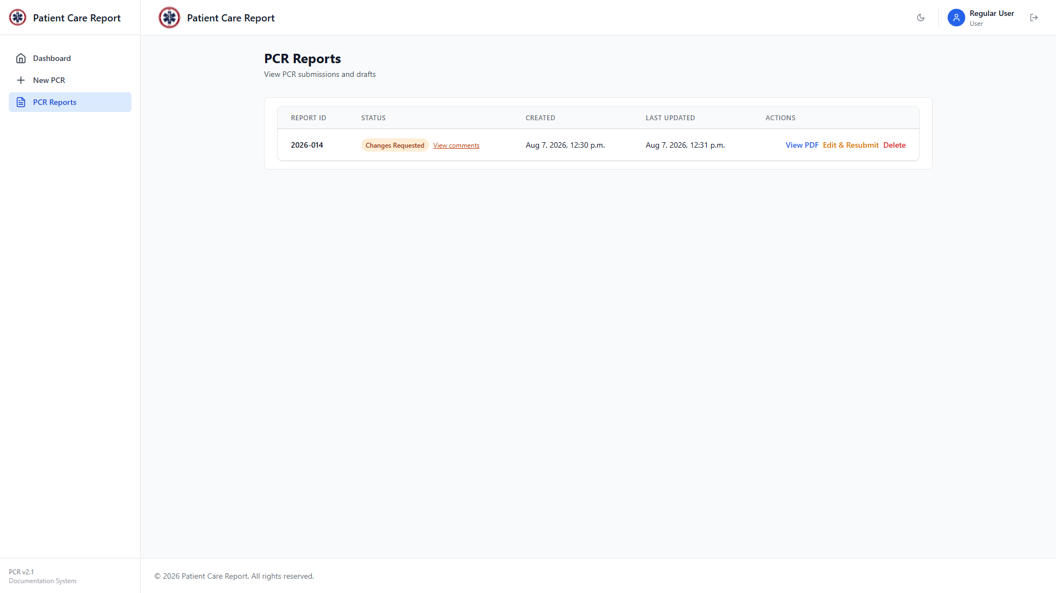
Figure 31. A report marked Changes Requested. Note that an approved report from the same session no longer appears in this list.
1. Click View comments next to the status to see exactly what the admin asked you to fix.
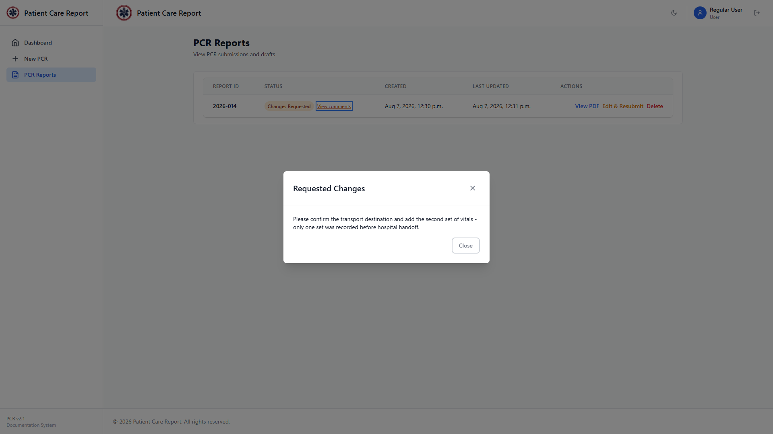
Figure 32. The admin's comments, shown in a read-only window.
2. Click Close, then click Edit & Resubmit.
3. The form reopens with everything you originally entered, plus a banner at the top repeating the admin's comments so you don't have to keep the other window open.
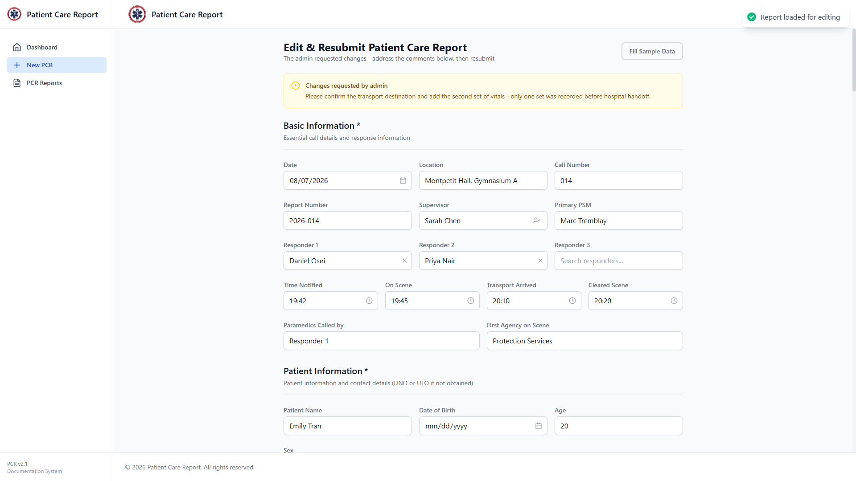
Figure 33. The form reopened for editing, with the admin's comments shown at the top.
4. Make the changes the admin asked for.
5. Click Submit PCR and go through the same preview-then-submit confirmation described in Section 9.
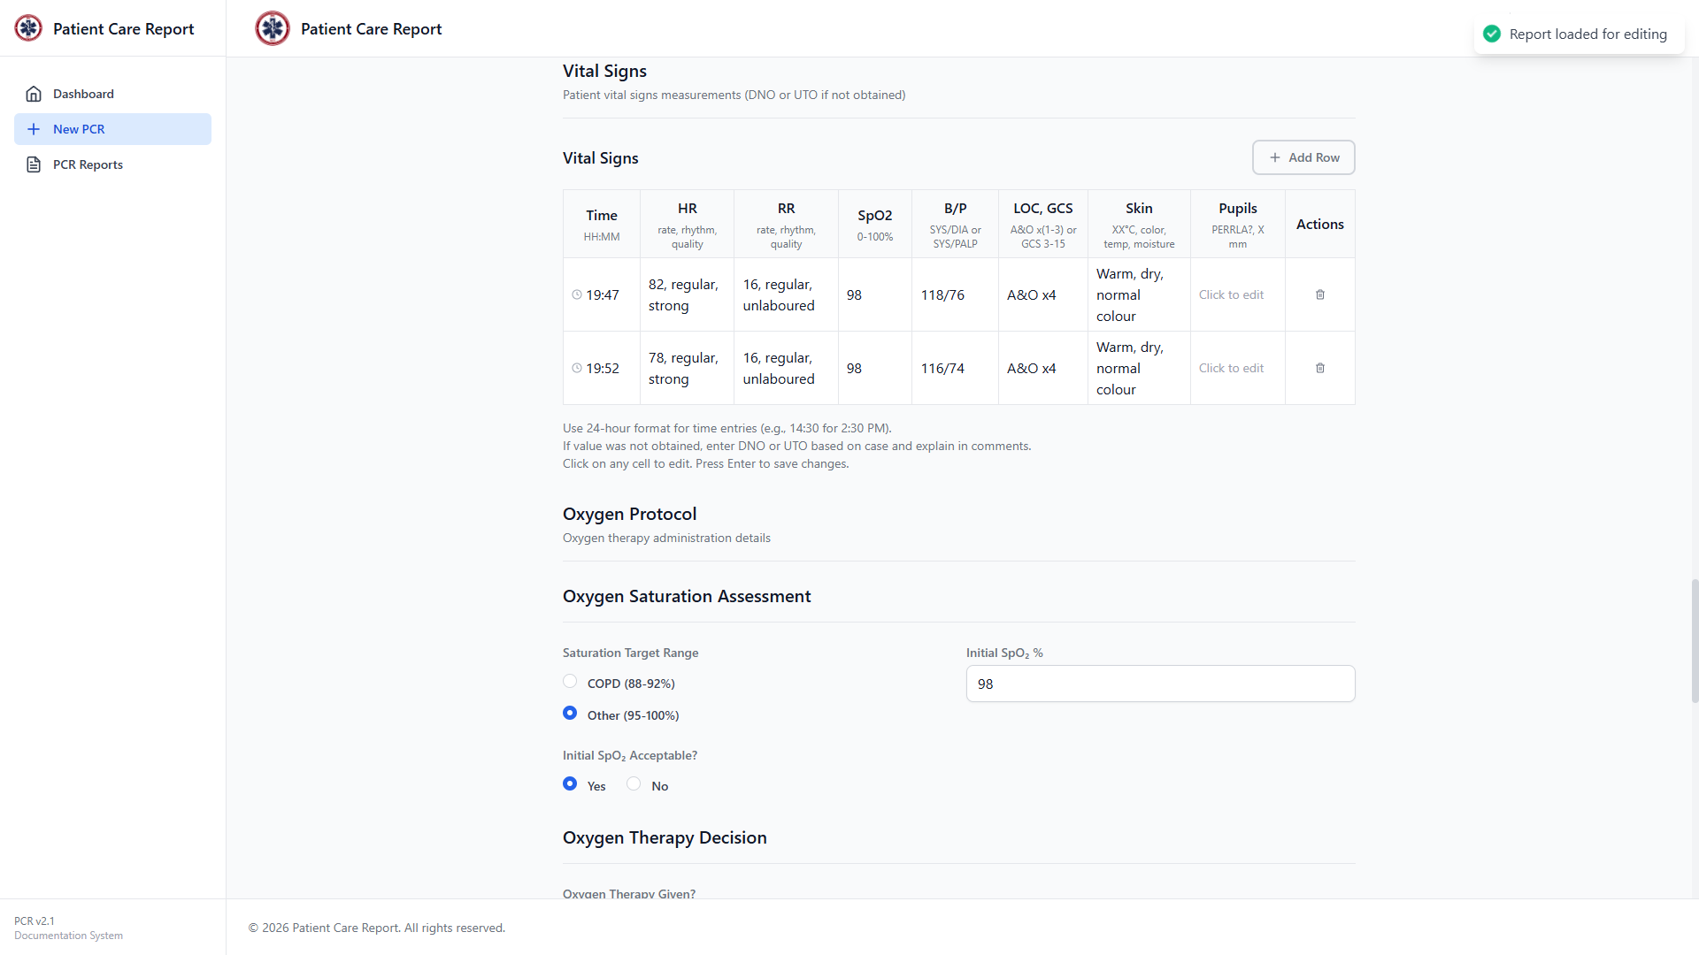
Figure 34. Reviewing the Vital Signs section while addressing the admin's feedback.
6. Once you confirm, the report goes back to Submitted status, the admin's comments are cleared, and it's back in the review queue.
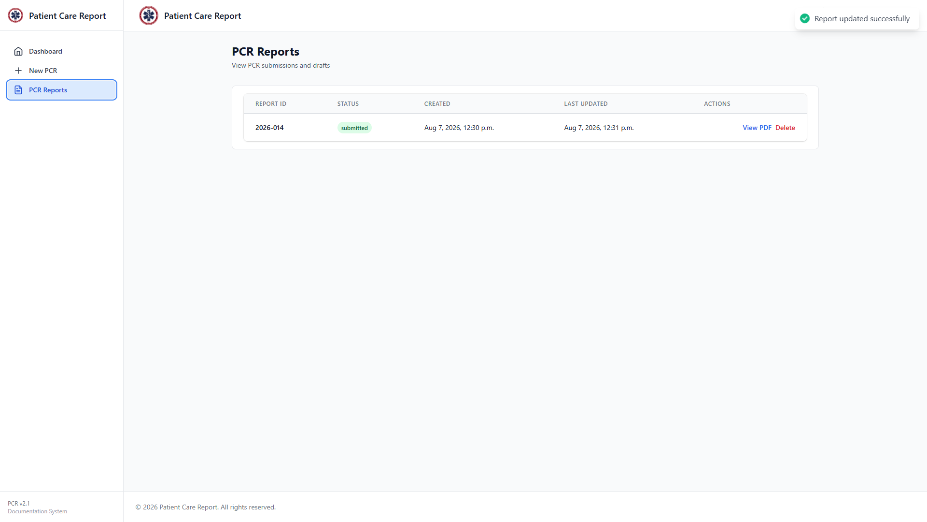
Figure 35. The report back to Submitted status after resubmission.
Note Only you, as the report's owner, can edit a report while it's in Changes Requested status. Once you resubmit it, it locks again just like any other submitted report.

13. Deleting a Draft
Click Delete on any draft's row in PCR Reports to remove it. You'll get a confirmation popup first — click OK to confirm or Cancel to back out.
Note Delete only appears on drafts. Once you submit a report, it belongs to the review workflow and only an admin can remove it from there — including if it's later sent back to you as Changes Requested. If you need a submitted report deleted, ask an admin.
Note Deleting is permanent. There's no undo.

14. Logging Out
Click the logout icon in the top-right corner, next to your name, at any time. You'll be returned to the login screen.

15. Quick Reference
Common questions, answered briefly:
- Why can't I see my approved report anymore?: Approved reports are removed from your list on purpose. Contact an admin if you need a copy.
- Why can't I edit a report I already submitted?: Submitted reports are locked until an admin either approves them or sends them back with Changes Requested. You can't edit a report that's actively awaiting review.
- I was signed out while filling out a form — did I lose my work?: Save Draft regularly if you're going to step away. A session timeout does not auto-save your progress.
- Can I submit more than one report?: Yes, there's no limit. Each one gets its own report number and moves through review independently.
- What's the difference between Edit and Edit & Resubmit?: They're the same action under different names. Edit & Resubmit only appears when a report is in Changes Requested status, as a reminder that you need to send it back once you're done.

